

**UNMANNED VESSEL FOR WATER POLLUTION MONITORING**

***Project Report submitted by***

|  |  |
| --- | --- |
| **ALDRIN SHOAN LEWIS**  **(4NM21EE006)** | **Cyrus Tejas Kairanna**  **(4NM21EE025)** |
| **Jitesh D Sanil**  **(4NM21EE032)** | **Kanishka Arun Kumar**  **(4NM21EE034)** |

***Under the Guidance of***

**Mr. Naveen J**

Assistant Professor Gd-III, Dept. of Electrical & Electronics Engineering

*In partial fulfillment of the requirements for the award of*

*the Degree of*

**Bachelor of Engineering in Electrical and Electronics Engineering**

*from*

***Visvesvaraya Technological University, Belagavi***

Department of Electrical and Electronics Engineering

NMAM Institute of Technology, Nitte - 574110

(An Autonomous Institution affiliated to VTU, Belagavi)

**NOVEMBER 2024**

**

DEPARTMENT OF Electrical and electronics ENGINEERING

CERTIFICATE

*Certified that the project work entitled*

*“* **UNMANNED VESSEL FOR WATER POLLUTION MONITORING***”*

*is a bonafide work carried out by*

**ALDRIN SHOAN LEWIS, CYRUS TEJAS KAIRANNA,**

**JITESH D SANIL, KANISHKA ARUN KUMAR**

**(4NM21EE006, 4NM21EE025, 4NM21EE032, 4NM21EE034)**

*in partial fulfilment of the requirements for the award of*

*Bachelor of Engineering Degree in* Electrical and Electronics Engineering

*prescribed b*y Visvesvaraya Technological University, Belagavi

*during the year 2024-2025.*

*It is certified that all corrections/suggestions indicated for Internal Assessment have been incorporated in the report deposited in the departmental library.*

*The project report has been approved as it satisfies the academic requirements in respect of the project work prescribed for the Bachelor of Engineering Degree.*

___________________ ___________________ _______________________

*Signature of the Guide Signature of the HOD Signature of the Principal*

Semester End Viva Voce Examination

Name of the Examiners Signature with Date

1. __________________________ __________________________

2. __________________________ __________________________

**ACKNOWLEDGEMENT**

The success and final outcome of this project required a lot of guidance and assistance from many people, and I am extremely fortunate to have got their support all along with the completion of our project.

I would also like to express my gratitude towards our principal Dr Niranjan N Chiplunkar for providing the facilities of the college premises.

I would also like to thank our vice principals Dr. Shrinivasa Rao B.R. and Dr. I. Ramesh Mithanthaya for supporting us.

I would also like to express my gratitude towards our Head of the Department Dr Suryanarayana K for giving us this great opportunity.

I take this opportunity to express my profound gratitude and deep regards to my Project Guide Mr. Naveen J, Assistant Professor GD-III, Department of Electrical and Electronics and Engineering for her exemplary guidance, monitoring, and constant encouragement throughout the course of this project.

I would further like to thank all the faculty members for their cooperation and extended support in undertaking the project work.

I also would like to thank the college for providing the infrastructure and facility in carrying out the projects like this. Without all their support and suggestions, this project would not have been possible.

Finally, I would like to thank my friends and classmates for constantly supporting me and helping me to complete this project.

# ABSTRACT

Water quality monitoring is critical for environmental preservation and safe water use, with current systems allowing for real-time, automated assessments of key parameters such as temperature, turbidity, pH, and total dissolved solids (TDS). This paper describes an IoT-based system that includes advanced hardware and software for continuous, remote water quality monitoring. Sensors wirelessly transfer data to the Arduino Cloud, which may be accessed by desktop or mobile devices and is used to study and manage parameter values. The device detects floating waste using an ultrasonic A220YUW sensor, which replicates radar functions and identifies visual pollution.

The study includes an unmanned vehicle controlled by an Arduino Nano RP2040 microcontroller that can cruise autonomously across numerous water bodies, including rivers, lakes, and ponds. Equipped with GPS tracking, the vessel can precisely map water quality variations by comparing location data to sensor readings. Its adaptive architecture immediately initiates corrective operations when measured values surpass safety levels, allowing for prompt response to adverse water quality changes. The vessel collects multi-parameter data, including as pH, TDS, turbidity, and temperature, at multiple locations and sends it to the cloud for continuous observation and analysis.

This application collected data from three different locations: a prawn farm, a river, and a rainwater-storing lake, with GPS coordinates associated with each site's readings. The combination of sensor data and GPS enables precise water quality mapping across habitats. The compact, scalable design, along with the vessel's remote and semi-automated operation, provides a long-term solution for large-scale, real-time water quality monitoring, increasing efficiency and responsiveness in environmental monitoring activities.

# TABLE OF CONTENTS

|  |  |  |
| --- | --- | --- |
| **CHAPTER**  **NUMBER** | **TITLE** | **PAGE NO.** |
| I | ABSTRACT | iv |
| 1 | INTRODUCTION | 1 – 4 |
| 2 | LITERATURE REVIEW | 5 – 7 |
| 3 | PROBLEM STATEMENT & REQUIREMENT  SPECIFICATION | 8 – 46 |
| 4 | METHODOLOGY | 47 – 49 |
| 5 | IMPLEMENTATION | 50 – 64 |
| 6 | RESULTS | 65 – 69 |
| 7 | CONCLUSION AND FUTURE  ENHANCEMENT | 70 – 72 |
| 8 | REFERENCES | 73 – 74 |

**LIST OF FIGURES**

|  |  |  |
| --- | --- | --- |
| **FIGURE**  **NUMBER** | **TITLE** | **PAGE**  **NO.** |
| Fig 1 | Arduino IDE | 10 |
| Fig 2 | Arduino cloud | 12 |
| Fig 3 | Arduino Nano RP2040 Connect | 14 |
| Fig 4 | PINOUT of A N RP2040 | 15 |
| Fig 5 | NodeMCU ESP8266 | 16 |
| Fig 6 | PINOUT of NodeMCU | 16 |
| Fig 7 | LM259s Module | 18 |
| Fig 8 | A02YYUW Ultrasonic  Sensor | 20 |
| Fig 9 | TDS Sensor | 21 |
| Fig 10 | Turbidity Sensor | 23 |
| Fig 11 | Turbidity PINOUT | 24 |
| Fig 12 | PINOUT of DS18B20 | 26 |
| Fig 13 | PH Sensor | 27 |
| Fig 14 | Servo | 28 |
| Fig 15 | ESC | 29 |
| Fig 16 | NEO-6M Module | 31 |
| Fig 17 | Regulator on GPS | 31 |
| Fig 18 | PINOUT of GPS | 32 |
| Fig 19 | BLDC Motor | 33 |
| Fig 20 | Li-PO Battery | 34 |
| Fig 21 | XT Connector | 35 |
| Fig 22 | Screw Pin Terminal | 37 |
| Fig 23 | FlySky Controller | 38 |
| Fig 24 | Zero PCB | 40 |
| Fig 25 | Jumper Cables | 41 |
| Fig 26 | Berg Strip | 42 |
| Fig 27 | Toggle Switch | 43 |
| Fig 28 | Autodesk Fusion360 | 44 |
| Fig 29 | Side View of 3d model | 46 |
| Fig 30 | Top View of 3d model | 46 |
| Fig 31 | Connection Diagram of Project | 50 |
| Fig 32 | Block Diagram of Project | 51 |

|  |  |  |
| --- | --- | --- |
| **TABLE NO** | **TITLE** | **PAGE NO** |
| Table 1 | Threshold Values | 16 |
| Table 2 | NodeMCU PIN CONFIG | 17 |
| Table 3 | Threshold Values of Ultrasonic Sensor | 20 - 21 |
| Table 4 | Threshold Values of Turbidity | 25 |
| Table 5 | Threshold Values of DS18B20 | 25 |
| Table 6 | Details of PH Sensor | 27 |
| Table 7 | Specifications of Servo | 28 - 29 |
| Table 8 | Specifications of GPS Sensor | 30 |
| Table 9 | BLDC Specifications | 33 |
| Table 10 | Battery Specifications | 34 - 35 |
| Table 11 | Specifications of XT Connector | 36 |
| Table 12 | Specification of Screw Pin Terminal | 37 |
| Table 13 | Berg Strip Specification | 42 |
| Table 14 | Switch Specifications | 43 |

**LIST OF TABLES**

**Chapter 1 INTRODUCTION**

Water quality monitoring is critical for assuring the safety and sustainability of water supplies, with direct implications for public health, environmental preservation, and a variety of industrial applications. Traditional methods of assessing water quality frequently rely on laboratory analysis and manual sampling, which are labor-intensive, time-consuming, and may not provide real-time insights into the water's health. Modern water quality monitoring systems have evolved to overcome these restrictions by automating data collecting, analysis, and administration while utilizing powerful hardware and software technologies.

The incorporation of Internet of Things (IoT) technology has significantly improved these systems by allowing for real-time monitoring of crucial water parameters such as temperature, turbidity, pH, and total dissolved solids (TDS). These indicators are critical for evaluating water quality and assuring adherence to safety standards established by organizations such as the World Health Organization. These systems are equipped with sensors that continuously collect data and wirelessly transmit it to cloud apps, allowing users to remotely monitor water conditions on desktop or mobile devices.

A fundamental element of this system is the employment of an unmanned, semi-automatic ship powered by an Arduino Nano RP2040 Connect CPU. This ship is outfitted with a variety of sensors, including a DS18B20 temperature sensor, turbidity sensor, pH sensor, and TDS sensor, all of which provide a comprehensive examination of water quality. To improve functioning, the system features an A02YYUW ultrasonic sensor mounted on a servo motor, which simulates radar technology to identify floating waste particles. This sensor not only measures distances to barriers, but it also helps locate visible debris, allowing for a more proactive approach to waste management in water bodies.

Furthermore, the unmanned watercraft is outfitted with an ESP8266 module and a GPS module for real-time tracking of its location. The ESP8266 functions as a communication link, sending GPS coordinates and sensor data to the Arduino Cloud platform. The incorporation of a GPS module allows customers to see the vessel's location on a dedicated cloud dashboard, allowing them to monitor pollution levels across many pond locations. A local web-based GPS tracking interface has also been developed to display real-time positional data via the device's IP address, giving users convenient access without relying entirely on the Arduino Cloud dashboard.

The data collected from the vessel is transferred to the Arduino Cloud for real-time viewing, analysis, and storage. The cloud dashboard displays a full picture of both water quality data and GPS tracking, providing an easy platform for monitoring and decision-making. Furthermore, the system contains a mechanism that would automatically commence corrective steps if any water quality parameters exceed safe levels, ensuring prompt reactions to possible problems. The compact, efficient design of this Arduino Nano RP2040-based system makes it perfect for scalable and long-term water quality monitoring in a variety of environmental scenarios.

In summary, this autonomous, GPS-enabled monitoring vessel offers an efficient, scalable solution for water quality analysis, combining advanced sensor arrays, cloud connectivity, and autonomous navigation to enable real-time environmental monitoring and better response to water quality concerns.

## 1.1 BACKGROUND

Water quality monitoring is critical for assuring the safety and sustainability of water resources since it has a direct impact on public health, environmental preservation, and a wide range of industrial applications. Clean water is essential for human health since contaminated sources can spread waterborne diseases, harming both human populations and aquatic ecosystems. Water quality is also critical for preserving biodiversity and ecosystem health, and sectors including agriculture, medicines, and food processing rely on high water standards to meet production and safety needs.

Traditional water quality monitoring methods frequently include manual sampling and laboratory testing, which, while accurate, have severe limitations. These techniques are labour-intensive, time-consuming, and need laboratory equipment and specialist workers, making them expensive and difficult to apply extensively, especially in remote or underserved areas. Furthermore, these technologies lack real-time capabilities, as there is frequently a delay between sample collection and data availability, restricting the ability to respond quickly to pollution incidents and emergent water quality issues.

Recent advances in Internet of Things (IoT) technology have significantly improved water quality monitoring by allowing for automated data collection, transfer, and analysis. IoT-based devices may now collect real-time data on critical water quality parameters like pH, turbidity, TDS, and temperature. These criteria provide a full picture of water quality, assisting in ensuring conformity to standards imposed by regulatory authorities such as the World Health Organization. Cloud connectivity enables IoT-enabled devices to wirelessly communicate sensor data to remote platforms, allowing users to monitor water conditions from nearly any place and on any device.

Cloud platforms play an increasingly important role in organizing and evaluating data from IoT-enabled water quality monitoring equipment. Platforms like the Arduino Cloud provide the scalable storage and presentation of real-time data, making it available for quick review and historical analysis. These platforms integrate with a variety of IoT devices, including the Arduino Nano RP2040, ESP8266, and GPS modules, allowing for seamless data transmission as well as the ability to trigger alarms and automate activities based on threshold circumstances. This allows for a quicker response to decreasing water quality, better management of water resources, and a reduction in potential health and environmental problems.

To increase the flexibility and reach of water quality monitoring, current systems also include autonomous and remote-controlled vessels. These vessels provide increased spatial coverage within water bodies, enabling for data collection at several locations within ponds, rivers, or reservoirs. Furthermore, modern sensors, such as the A02YYUW ultrasonic sensor, which replicates radar, allow these ships to detect visible floating garbage and avoid obstructions. By decreasing the need for human interaction, these autonomous systems increase monitoring safety and efficiency, particularly in dangerous or difficult-to-access situations.

GPS integration is another key component of modern water quality monitoring, allowing for exact, location-based tracking of pollutant levels. By correlating sensor data with particular geographic coordinates, GPS-equipped devices provide a comprehensive view of water quality across multiple sites, which is critical for identifying pollution sources and patterns. Using the ESP8266 module, the system can transfer GPS data in real time to a cloud dashboard and a local, web-based interface that displays the vessel's position based on its IP address. Recent improvements in low-cost GPS technology allow for the cost-effective implementation of these characteristics, making them more accessible to a larger range of environmental monitoring applications.

This project addresses the demand for scalable, cost-effective water quality monitoring systems by implementing a real-time, IoT-enabled, GPS-integrated system. Unlike previous approaches, which are constrained by delayed data and high labour requirements, this system allows for autonomous, continuous data gathering and processing, providing current information about water conditions. The project's compact and efficient design, based on the Arduino Nano RP2040 and supported by cloud and GPS functionality, helps significantly to environmental preservation and public health goals by providing a dependable, modern solution for sustainable water resource management.

**Chapter 2 LITERATURE REVIEW**

In 2020 Pasika et al. [1] proposed an intelligent water quality monitoring system that utilized IoT in a costeffective way. They used a pH sensor, turbidity sensor, water level sensor, temperature sensor, and humidity sensor. They used an Arduino board as a microcontroller board. They found that their proposed framework works efficiently. In 2023, Bogdan et al. [2] proposed an inexpensive water quality monitoring system. They developed a low-cost Internet of Things (IoT) system that monitors the quality of different water sources and publishes its findings. The system consists of an Arduino UNO board and various sensors, is controlled through a mobile app. After monitoring five water sources in a rural area, the findings indicate that most were suitable for consumption, except for one where TDS values exceed the accepted limit of 500 ppm. In 2023, Razman et al. [3] proposed a water quality monitoring system. They proposed an Arduino-based system for monitoring and filtering water quality. They used Proteus software to simulate the design and ThingSpeak for real-time tracking. They compared various water quality parameters of tap water, lake water, and river water. When water quality wasn’t good enough, a filtration device was turned on. Following international and state standards for water quality, tests were done to compare filtered and unfiltered water. For strong data validation, statistical tools like box plots and one-way analysis of variance were used. Using wireless fidelity, the real-time monitoring system made it easier for users to get info through ThingSpeak. Their study laid the groundwork for future research on systems that check for pollution in lakes and rivers, and it could be used to build bigger systems for main tanks in homes or workplaces.

Before going into the details of our Intelligent IoT based Water Quality Monitoring system, we will review some of the existing system in vogue pertaining to Water Quality. In the traditional water quality monitoring system, different instruments been used to monitor the quality of water which include “Secchi disks (measure water clarity), probes, nets, gauges, meters”, etc. The traditional method is just not enough to measure water quality and identify any drastic changes in it. In the 21st century, there were lots of inventions, but at the same time the water pollution problem is also formed widely specially in coastal areas. Nikhil Kedia entitled “Water Quality Monitoring for Rural Areas-A Sensor Cloud Based Economical Project.” Published in 2015 1st International Conference on Next Generation Computing Technologies (NGCT-2015) Dehradun, India. This paper features water quality observing strategies, sensors, and data dissemination method, role of government, organize administrator and locals in guaranteeing legitimate data dispersal. It likewise investigates the Sensor Cloud space. While consequently improving the water quality isn't possible now, effective utilization of innovation and financial practices can help improve water quality and mindfulness among individuals. [4] Jayti Bhatt, Jignesh Patoliya entitled “Real Time Water Quality Monitoring System”. This paper portrays to

guarantee the safe supply of drinking water the quality ought to be observed progressively for that reason new approach IOT (Internet of Things) based water quality checking has been proposed. In this paper, we present the design of IOT based water quality observing system that screen the nature of water progressively. This system comprises a few sensors which measure the water quality parameter, for example, pH, turbidity, temperature.[5] Sokratis Kartakis, Weiren Yu, Reza Akhavan, and Julie A. McCann entitled “Adaptive Edge Analytics for

Distributed Networked Control of Water Systems”. This paper shows the burst location and confinement plot that joins lightweight pressure and inconsistency discovery with diagram topology examination for water distribution networks. We show that our methodology altogether diminishes the number of communications between sensor devices and the back-end servers. Our results can save up to 90% communications compared with traditional periodical reporting situations. [6]

Nikhil Kedia entitled “Water Quality Monitoring for Rural Areas-A Sensor Cloud Based Economical Project.” Published in 2015 1st International Conference on Next Generation Computing Technologies (NGCT-2015) Dehradun, India. This paper highlights the entire water quality monitoring methods, sensors, embedded design, and information dissipation procedure, role of government, network operator and villagers in ensuring proper information dissipation. It also explores the Sensor Cloud domain. While automatically improving the water quality is not feasible at this point, efficient use of technology and economic practices can help improve water quality and awareness among people.[7]

Michal Lom, Ondrej Pribyl, Miroslav Svitek entitled “Industry 4.0 as a Part of Smart Cities”. This paper describes the conjunction of the Smart City Initiative and the concept of Industry 4.0. The term smart city has been a phenomenon of the last years, which is very inflected especially since 2008 when the world was hit by the financial crisis. The main reasons for the emergence of the Smart City Initiative are to create a sustainable model for cities and preserve quality of life of their citizens. The topic of the smart city cannot be seen only as a technical discipline, but different economic, humanitarian or legal aspects must be involved as well. In the concept of Industry 4.0, the Internet of Things (IoT) shall be used for the development of so–called smart products. Subcomponents of the product are equipped with their own intelligence. Added intelligence is used both during the manufacturing of a product as well as during subsequent handling, up to continuous monitoring of the product lifecycle (smart processes). Other important aspects of the industry 4.0 are Internet of Services (IoS), which includes especially intelligent transport and logistics (smart mobility, smart logistics), as well as Internet of Energy (IoE), which determines how the natural resources are used in proper way (electricity, water, oil, etc.). IoT, IoS, IoP and IoE can be considered as an element that can create a connection of the Smart City Initiative and Industry 4.0 – Industry 4.0 can be seen as a part of smart cities.[3]

Sokratis Kartakis, Weiren Yu, Reza Akhavan, and Julie A. McCann entitled “Adaptive Edge Analytics for Distributed Networked Control of Water Systems” This paper presents

the burst detection and localization scheme that combines lightweight compression and anomaly detection with graph topology analytics for water distribution networks. We show that our approach not only significantly reduces the number of communications between sensor devices and the back-end servers, but also can effectively localize water burst events by using the difference in the arrival times of the vibration variations detected at sensor locations. Our results can save up to 90% communications compared with traditional periodical reporting situations. [8]

# Chapter 3 POBLEM STATEMENT & RREQUIREMENT SPECIFICATION

## PROBLEM STATEMENT

Water quality monitoring is critical for protecting human health, biodiversity, and assuring industrial and agricultural safety. Pollutants and contaminants in water bodies, such as chemical runoff, trash discharge, and other pollutants, pose major threats, resulting in toxic algal blooms, bioaccumulation of hazardous compounds, and extensive health concerns for human populations who rely on these water sources. Current water quality evaluation methods rely mainly on traditional approaches such as manual sampling and laboratory testing, which, while useful for detailed analysis, have significant limits. These traditional methods are labor-intensive, expensive, and time-consuming, frequently causing large delays between data gathering and actionable insights.

One of the primary disadvantages of traditional monitoring technologies is their inability to offer real-time information about water quality. This time lag can be problematic, particularly in situations where quick action is required to prevent future contamination or to reduce ongoing pollution occurrences. Furthermore, hand sampling necessitates significant human resources and is logistically demanding, especially in remote or difficult-to-access locations. Continuous coverage across huge bodies of water becomes problematic due to limited spatial and temporal reach, rendering traditional monitoring ineffective for complete, real-time water quality observation.

Advances in Internet of Things (IoT) technology have made automated and remote water quality monitoring solutions possible, overcoming many of these constraints. IoT-based water monitoring systems allow for continuous data collection and wireless transfer of water parameters, resulting in real-time insights and timely decision-making. However, many existing IoT-enabled water quality monitoring technologies continue to have drawbacks. They frequently rely on static sensor placements or expensive equipment and may lack advanced data visualization and analytics, which are required for deciphering complicated water quality dynamics. Furthermore, the high-power consumption of these devices may limit the operating lifetime and scalability of existing systems. Many IoT solutions lack location-tracking capabilities, making it difficult to properly monitor multiple regions within a single body of water. Given these restrictions, there is an urgent need for a more adaptive and self-sufficient water quality monitoring system. This project offers an IoT-enabled, autonomous surface vessel with advanced sensors and cloud-based data management for real-time water quality monitoring. This vessel is designed to run autonomously across water bodies and will continually measure essential water quality indicators such as pH, temperature, turbidity, and total dissolved solids (TDS) before transmitting the data to a centralized cloud platform for real-time visualization and analysis. The system's integration with a GPS module will enable accurate location-based tracking, spatial data collecting across numerous places in a water body, and more thorough environmental assessments.

The core microcontroller for the proposed system will be the Arduino Nano RP2040, with data being transferred to the Arduino Cloud via an ESP8266 module. This configuration will provide for effective data gathering and cloud-based access to real-time data visualizations on PCs and mobile devices, empowering stakeholders to monitor water quality remotely. Furthermore, the system will have automatic alerting capabilities that will initiate corrective operations when water parameters surpass predefined levels, ensuring a quick reaction to possible pollution incidents. The unmanned vessel's semi-automatic or remote-control capability enables it to navigate aquatic bodies autonomously, avoiding the need for considerable human interaction and lowering operational expenses. By implementing a scalable, real-time monitoring solution, this project aims to address the critical challenges of current water quality monitoring approaches and provide a sustainable, efficient alternative suitable for large-scale environmental monitoring applications.

## OBJECTIVES

1. To develop a Real-time Water Quality Monitoring
2. To implement Data Collection and Analysis
3. To ensure Compliance with Water Safety Standards
4. To implement automation and enable remote control functionality
5. To detect obstructions and waste in the water.

# SOFTWARE SPECIFICATION

## Arduino IDE

The Arduino Integrated Development Environment (IDE) is the primary development environment for this project, where code is written, tested, and deployed to the Arduino Nano RP2040 Connect. The Arduino IDE is a simple, user-friendly interface that is required for efficient programming and debugging, and it supports a wide range of Arduino-compatible devices and sensors. In this project, the IDE was widely used to integrate and control numerous sensors (temperature, pH, TDS, turbidity, and ultrasonic) with the Arduino Nano RP2040 Connect, allowing us to collect exact data and run the unmanned vessel efficiently.

The Arduino IDE was used as follows:

Figure 1 Arduino IDE

* **Code Development and Testing**: The IDE supports C++ programming, which enabled the development of modular code to read data from various sensors and control hardware components, such as the BLDC motors and servo motors. Each sensor required specific libraries (e.g., OneWire for the temperature sensor) to communicate with the Arduino Nano RP2040. The IDE’s code editor provided syntax highlighting, auto-indentation, and a serial monitor, enhancing the efficiency and accuracy of the code development process.
* **Library Management**: The Arduino IDE offers access to a vast library of pre-built functions, which streamlined the integration of sensors and actuators with the Arduino. Libraries for each sensor type were added through the Library Manager, simplifying code structure and ensuring compatibility. These libraries facilitated sensor calibration and data conversion processes for the pH, turbidity, TDS, and temperature sensors.
* **Serial Monitor for Debugging**: One of the crucial features of the Arduino IDE in this project was the Serial Monitor, which allowed real-time display of sensor readings for testing and debugging purposes. By monitoring the serial output, we were able to validate data from each sensor, adjust code logic, and troubleshoot any issues before deployment. This was essential for calibrating the sensors accurately and verifying that data was transmitted correctly from the sensors to the microcontroller.
* **Uploading Code to Hardware**: Using the Arduino IDE’s straightforward interface, code was easily uploaded to the Arduino Nano RP2040 Connect via a USB connection. This streamlined the process of making iterative changes to the system, testing, and refining code until the desired functionality was achieved.
* **ESP8266 Wi-Fi Module Configuration:** The Arduino IDE was also required for configuring and programming the ESP8266 module, which allowed wireless data transmission to the Arduino Cloud. Custom settings and code were created in the IDE to establish a robust Wi-Fi connection, ensuring that the Arduino Nano RP2040 communicates with the cloud platform. This procedure included using libraries like WiFi.h and setting the ESP8266 to send real-time data from the vessel's sensors to the Arduino Cloud. Using the Serial Monitor in the IDE, we were able to troubleshoot and verify that the ESP8266 was successfully connected to Wi-Fi and consistently sending data, which streamlined the cloud integration process.

The Arduino IDE made rapid programming and testing possible, allowing the project to create a robust, trustworthy system capable of gathering and processing water quality data effectively. The IDE's modular, open-source design, as well as its wide library support, making it an essential tool for integrating the project's various sensors and components.

## Arduino Cloud

The Arduino Cloud provides an easily accessible, centralized platform for remote data storage, visualization, and management, which is essential for this real-time water quality monitoring project. This platform allows sensor data from the Arduino Nano RP2040 Connect to be wirelessly transferred via an ESP8266 module, allowing for continuous real-time monitoring of water parameters such as temperature, pH, turbidity, and TDS. The Arduino Cloud is specifically developed to support IoT applications by providing an integrated solution for data streaming, visualization, and remote access.

Figure 2 Arduino Cloud

In this project, the Arduino Cloud was utilized in several key ways:

* **Real-Time Data Visualization:** We utilized the Arduino Cloud dashboard to construct a visual interface for monitoring each water quality indicator. Customizable widgets enabled unique graphical representations of each parameter, making the data easier to grasp at a glance. For example, pH and TDS data were displayed on separate graphs, allowing for quick assessment of any changes in water quality.
* **Remote Access for Monitoring**: The cloud-based dashboard allows users to watch the vessel's sensor data in real time without physically being there at the monitoring point. This is especially effective in dynamic contexts where constant, remote monitoring is required, allowing for responsive water quality management.
* **Alert Notifications**: The Arduino Cloud provides automated alert features, enabling users to set threshold values for each water quality parameter. When sensor readings deviate from safe ranges, notifications can be sent to alert users, facilitating immediate corrective actions. This feature is crucial for timely responses to environmental changes, such as sudden pollution spikes or dangerous pH levels, ensuring the system can act as an early warning tool.
* **Data Storage and Analysis**: The Arduino Cloud securely stores historical data, allowing for further analysis over time. This historical data is essential for tracking trends in water quality, evaluating the effectiveness of any corrective measures, and understanding long-term environmental impacts. By analyzing this data, users can make data-driven decisions to improve water quality management and resource allocation.

# HARDWARE SPECIFICATION

# ARDUINO NANO RP2040 CONNECT

Figure 3 Arduino Nano RP2040 Connect

# The feature packed Arduino® Nano RP2040 Connect brings the new Raspberry Pi RP2040 microcontroller to the Nano form factor. Make the most of the dual core 32-bit Arm® Cortex®-M0+ to make Internet of Things projects with Bluetooth and WiFi connectivity thanks to the U-blox® Nina W102 module. Dive into real-world projects with the onboard accelerometer, gyroscope, RGB LED and microphone. Develop robust embedded AI solutions with minimal effort using the Arduino® Nano RP2040 Connect!

# The RP2040 controls the peripherals and digital pins, as well as analog pins (A0-A3). The I2C connections on pins A4 (SDA) and A5 (SCL) are used for connecting to the onboards peripherals and are pulled up with a 4.7 kΩ resistor. SWD Clock line (SWCLK) and reset are also pulled up with a 4.7 kΩ resistor. An external MEMS oscillator (U7) running at 12MHz provides the clock pulse. Programmable IO helps to the implementation of arbitrary communication protocol with minimal burden on the main processing cores. A USB 1.1 device interface is implemented on the RP2040 for uploading code.

**Features**

**Raspberry Pi RP2040** Microcontroller

* 133MHz 32bit Dual Core Arm® Cortex®-M0+ 264kB on-chip SRAM
* Direct Memory Access (DMA) controller
* Support for up to 16MB of off-chip Flash memory via dedicated QSPI bus USB 1.1 controller and PHY, with host and device support
* 8 PIO state machines
* Programmable IO (PIO) for extended peripheral support
* 4 channel ADC with internal temperature sensor, 0.5 MSa/s, 12-bit conversion SWD Debugging
* 2 on-chip PLLs to generate USB and core clock 40nm process node
* Multiple low power mode support USB 1.1 Host/Device
* Internal Voltage Regulator to supply the core voltage
* 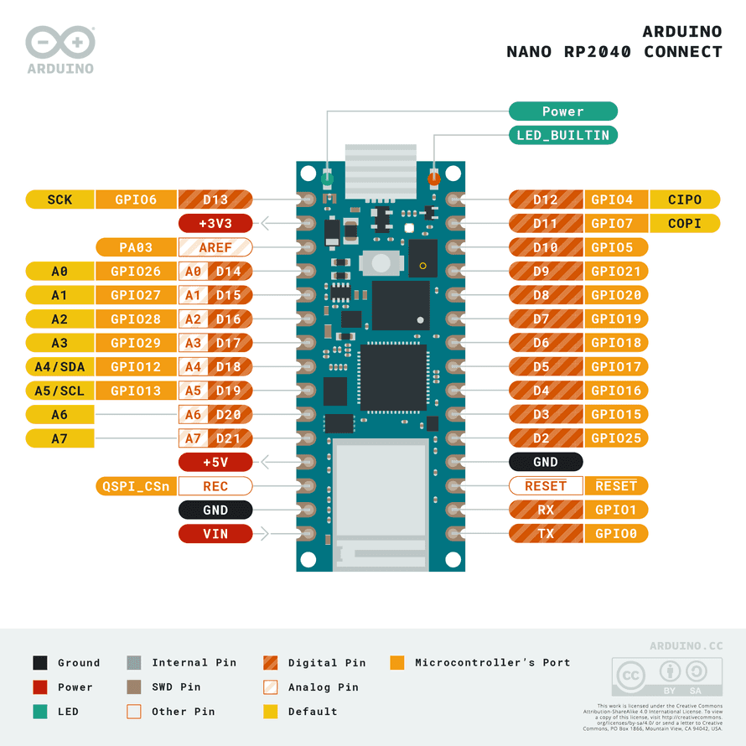Advanced High-performance Bus (AHB)/Advanced Peripheral Bus (APB)

Figure 4 PINOUT of A N RP2040

Table 1 Threshold Values

|  |  |  |  |  |  |
| --- | --- | --- | --- | --- | --- |
| Symbol | Description | Min | Typ | Max | Unit |
| VIN | Input voltage from VIN pad | 4 | 5 | 20 | V |
| VUSB | Input voltage from USB connector | 4.75 | 5 | 5.25 | V |
| V3V3 | 3.3V output to user application | 3.25 | 3.3 | 3.35 | V |
| I3V3 | 3.3V output current (including onboard IC) | - | - | 800 | mA |
| VIH | Input high-level voltage | 2.31 | - | 3.3 | V |
| VIL | Input low-level voltage | 0 | - | 0.99 | V |
| IOH Max | Current at VDD-0.4 V, output set high |  |  | 8 | mA |
| IOL Max | Current at VSS+0.4 V, output set low |  |  | 8 | mA |
| VOH | Output high voltage, 8 mA | 2.7 | - | 3.3 | V |
| VOL | Output low voltage, 8 mA | 0 | - | 0.4 | V |
| TOP | Operating Temperature | -20 | - | 80 | °C |

# NODEMCU ESP8266

[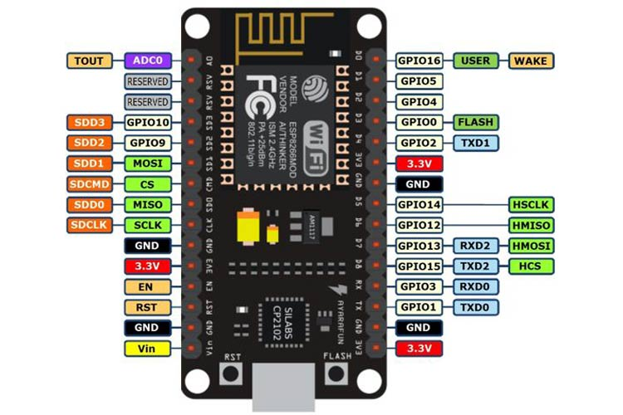](https://components101.com/sites/default/files/component_pin/NodeMCU-ESP8266-Pinout.jpg)[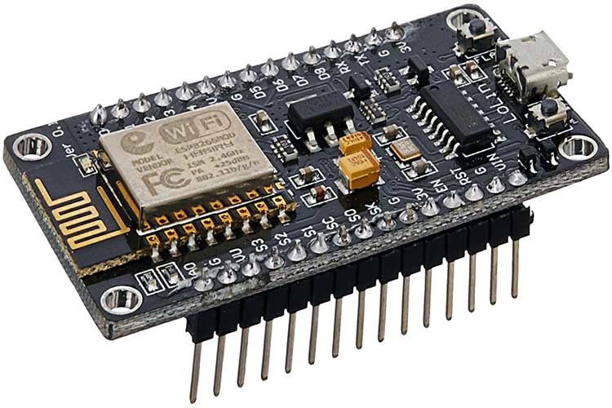](https://components101.com/sites/default/files/components/ESP8266-NodeMCU.jpg)

Figure 5 NodeMCU ESP8266

Figure 6 PINOUT of NodeMCU

**NodeMCU ESP8266 Pinout**

NodeMCU is an open-source Lua based firmware and **development board** specially targeted for IoT based Applications. It includes firmware that runs on the ESP8266 Wi-Fi SoC from Espressif Systems, and hardware which is based on the ESP-12 module.

Table 2 NodeMCU PIN CONFIG

|  |  |  |
| --- | --- | --- |
| Pin Category | Name | Description |
| Power | Micro-USB, 3.3V, GND, Vin | Micro-USB: NodeMCU can be powered through the USB port  3.3V: Regulated 3.3V can be supplied to this pin to power the board  GND: Ground pins  Vin: External Power Supply |
| Control Pins | EN, RST | The pin and the button reset the microcontroller |
| Analog Pin | A0 | Used to measure analog voltage in the range of 0-3.3V |
| GPIO Pins | GPIO1 to GPIO16 | NodeMCU has 16 general purpose input-output pins on its board |
| SPI Pins | SD1, CMD, SD0, CLK | NodeMCU has four pins available for SPI communication. |
| UART Pins | TXD0, RXD0, TXD2, RXD2 | NodeMCU has two UART interfaces, UART0 (RXD0 & TXD0) and UART1 (RXD1 & TXD1). UART1 is used to upload the firmware/program. |
| I2C Pins |  | NodeMCU has I2C functionality support but due to the internal functionality of these pins, you have to find which pin is I2C. |

**NodeMCU ESP8266 Specifications & Features**

* Microcontroller: Tensilica 32-bit RISC CPU Xtensa LX106
* Operating Voltage: 3.3V
* Input Voltage: 7-12V
* Digital I/O Pins (DIO): 16
* Analog Input Pins (ADC): 1
* UARTs: 1
* SPIs: 1
* I2Cs: 1
* Flash Memory: 4 MB
* SRAM: 64 KB
* Clock Speed: 80 MHz
* USB-TTL based on CP2102 is included onboard, Enabling Plug n Play
* PCB Antenna
* Small Sized module to fit smartly inside your IoT projects

**Applications**

* Prototyping of IoT devices
* Low power battery operated applications
* Network projects
* Projects requiring multiple I/O interfaces with Wi-Fi and Bluetooth functionalities

# DC-DC Buck Converter

Figure 7 LM259s Module

# LM2596S DC-DC Buck Converter Power Supply

1. Input voltage: 3-40V
2. Output voltage: 1.5-35V(Adjustable)
3. Output current: Rated current is 2A, maximum 3A
4. Switching Frequency: 150KHz
5. Operating temperature: Industrial grade (-40 to +85 )
6. Conversion efficiency: 92%(highest)

DC-DC Buck Converter Step Down Module LM2596 Power Supply is a step-down(buck) switching regulator, capable of driving a 3-A load with excellent line and load regulation. These devices are available in fixed output voltages of 3.3 V, 5 V, 12 V, and an adjustable output version.

The LM2596 series operates at a switching frequency of 150kHz, thus allowing smaller sized filter components than what would be required with lower frequency switching regulators.

This is an LM2596 DC-DC buck converter step-down power module with the high-precision potentiometer, capable of driving a load up to 3A with high efficiency, which can work with Freedonia UNO, other mainboards, and basic modules. When the output current keeps greater than 2.5A (or output power greater than 10W), please add a heat sink to it.

Features:

1. Input voltage:3-40V
2. Output voltage:1.5-35V(Adjustable)
3. Output current: Rated current is 2A, maximum 3A(Additional heatsink is required)
4. Module Properties: non-isolated constant voltage module
5. Rectification: non-synchronous rectification
6. Short circuit protection: current limiting, since the recovery

# ULTRASONIC SENSOR

**A02YYUW Waterproof Ultrasonic Sensor**

An ultrasonic distance sensor uses ultrasonic waves to determine the distance to a target object. This particular ultrasonic sensor module is designed for commercial use and has a high level of performance and reliability. It has a smaller "blind zone" than other similar sensors, meaning it is able to detect objects closer to it, and has a wider sensing angle, allowing it to detect objects from a greater range of angles. In addition, this sensor has the ability to penetrate through certain substances such as smog and dust, allowing it to still function effectively in these conditions.

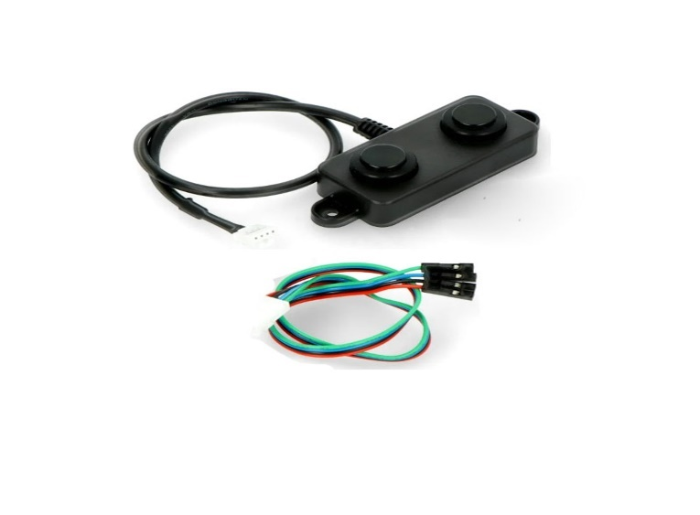

Figure 8 A02YYUW Ultrasonic Sensor

The ultrasonic sensor has a closed and sealed probe, making it waterproof and dustproof. This makes it suitable for use in harsh and moist environments. The sensor's signal processing units are integrated within the module, allowing users to easily obtain distance measurements through the asynchronous serial interface. With a 9600 bit/s bandwidth, the sensor can easily communicate with upper-host systems or other microcontroller units (MCUs), reducing the development time for users.

Table 3 Threshold Values of Ultrasonic Sensor

|  |  |
| --- | --- |
| BRAND | DF ROBOT |
| OPERATING VOLTAGE | 3.3~5V |
| CURRENT(AVG) | < 8Ma |
| BLIND ZONE DISTANCE | 3cm |
| OUTPUT | 3-450cm |
| RESPONSE TIME | 100ms |
| OPERATING TEMPETARURE | -15~60C |
| STORAGE TEMPERATURE | -25~80C |
| REFERENCE ANGLE | 60 deg |
| WATERPROOF GRADE | IP67 |

# TDS SENSOR

# Analog TDS Sensor Water Conductivity Sensor Module Board Kit is an Arduino-compatible TDS sensor/Meter Kit for measuring TDS value of the water. It can be applied to domestic water, hydroponic and other fields of water quality testing. This TDS sensor Arduino compatible supports 3.3 ~ 5.5V wide voltage input, and 0 ~ 2.3V analog voltage output, which makes it compatible with 5V or 3.3V control systems or boards. TDS sensor kit is compatible with Arduino controllers, plug and play, easy to use. Description

# It can be applied to measure TDS value of the water, to reflect the cleanliness of the water. TDS (Total Dissolved Solids) indicates that how many milligrams of soluble solids dissolved in one liter of water. In general, the higher the TDS value, the more soluble solids dissolved in water, and the less clean the water is. Therefore, the TDS value can be used as one of the references for reflecting the cleanliness of water.

Figure 9 TDS Sensor

# Measuring the TDS value in the water is to measure the total amount of various organic or inorganic substances dissolved in water, in the unit of ppm or milligrams per liter (mg/l). Its Electrode can measure conductive materials, such as suspended solids, heavy metals and conductive ions in water. The module comes with four 3.2mm fixed holes, easy to mount on any other devices. The TDS probe is waterproof, it can be immersed in water for long time measurement.

# Features:

# • Wide voltage operation: 3.3~5.5V

# • 0~2.3V analog signal output, compatible with 5V, 3.3V two control systems

# • The excitation source is an AC signal, effectively preventing probe polarization

# • Waterproof probe for long-term immersion in water

# • Arduino compatible, easy to connect, plug and play, no soldering required

# Specifications:

# TDS Sensor Module:

# • Input Voltage: DC 3.3 ~ 5.5V

# • Output Voltage: 0 ~ 2.3V

# • Working Current: 3 ~ 6mA

# • TDS Measurement Range: 0 ~ 1000ppm

# • TDS Measurement Accuracy: ± 10% F.S. (25 ℃)

# • Module Interface: XH2.54-3P

# • Electrode Interface: XH2.54-2P

# TDS Probe:

# • Number of Needle: 2

# • Total Length: 83cm

# • Connection Interface: XH2.54-2P

# • Color: White

# • Other: Waterproof Probe

# TURBIDITY SENSOR

A turbidity liquid particle detection sensor is a device that is used to measure the turbidity, or cloudiness, of a liquid. Turbidity is often used as an indication of the presence of suspended particles in the liquid, such as dirt, algae, or bacteria.

The sensor works by shining a light through the liquid and measuring the amount of light that is scattered or absorbed by the particle detection.

Turbidity is the measurement of particulate matter in water. It requires the analog port of the MCU to read the analog value for calculation. It needs turbidity calibration liquid to calibrate. It is not the multimeter that directly measures the voltage.

The output voltage of each module is different. The module should be protected from light and light. The temperature and voltage will make the output voltage of the module different.

These decisions are made on the basis of a comparison between clean water measurements (taken at the beginning of the wash cycle) and the wash water turbidity measurement taken at the end of each wash cycle.

By measuring the turbidity of the wash water, the dishwasher can conserve energy on lightly soiled loads by only washing as long as necessary. This will result in energy savings for the consumer.

Figure 10 Turbidity Sensor

**Parameters of the Turbidity Particle Sensor:**

**It is used to detect particles that is suspended in water**

* Voltage: 3.3-5V DC (with anti-reverse circuit)
* Current max : 30 mA
* Output: default analog (can set high and low output)
* Measuring range: 0-1000 NTU

**Key Features:**

* Turbidity can be measured in the range of 0 to 1000 Nephelometric Turbidity Units (NTU).
* Operates at 3.3-5V and has built-in anti-reverse circuitry for safety.
* The operating temperature range is from -20°C to 80°C.
* Uses light scattering or absorption to estimate the presence of suspended particles in liquids.
* Used in various applications such as water quality monitoring, environmental monitoring, and industrial processes.

**Turbidity Liquid Particle Detection Sensor Pin Diagram:**

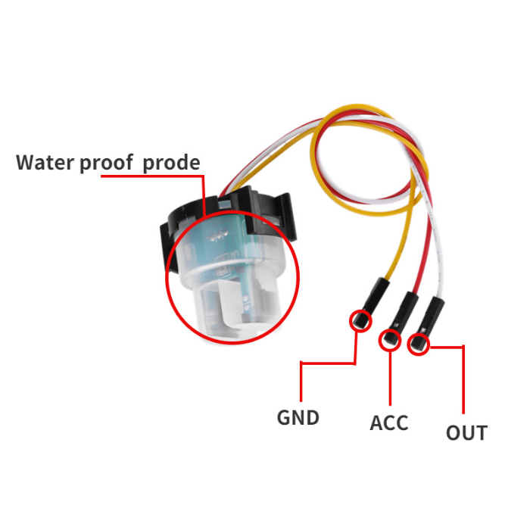

Figure 11 Turbidity PINOUT

Table 4 Threshold Values of Turbidity

|  |  |
| --- | --- |
| Type | Logic ICs |
| Operating Temperature | -20~80 celsius |
| Supply Voltage | 3.3-5V |
| Dimensions | 5 x 5 x 5cms |
| Weight | 35 grams |

# TEMPERATURE SENSOR

**DS18B20 WATERPROOF TEMPERATURE SENSOR:**

The DS18B20 is a 1-Wire® temperature sensor manufactured by Dallas Semiconductor (acquired by Maxim Integrated). Because it is a 1-wire device, it only needs one digital pin to communicate with the microcontroller.

The sensor is typically available in two form factors. One comes in a TO-92 package, which resembles a simple transistor. The other comes in the form of a waterproof probe, which is more useful when measuring something far away, underwater, or beneath the ground.

Table 5 Threshold Values of DS18B20

|  |  |
| --- | --- |
| Supply voltage | 3.0 – 5.5V |
| Temperature range | -55 ~ +125 °C |
| Probe diameter | 6mm |
| Probe length | 50mm |
| Resolution | 9 ~ 12 bit |
| Query time | 750 msec |
| Packaging Dimensions | 7 x 5 x 3 cms |
| Weight | 25 grams |
| RESOLUTION | 9 TO 12 BITS (SELECTABLE) |

The DS18B20 temperature sensor is fairly precise and does not require any external components to function. It has a temperature range of -55°C to +125°C and an accuracy of ±0.5°C.

The temperature sensor’s resolution can be set to 9, 10, 11, or 12 bits. The default resolution at power-up, however, is 12-bit (i.e., 0.0625°C precision).

The sensor operates on a 3V to 5.5V power supply and draws only 1mA during active temperature conversions.

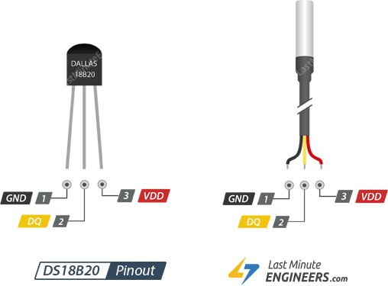GND is the ground pin.

Figure 12 PINOUT of DS18B20

DQ is a 1-Wire Data Bus that should be connected to a digital pin on the microcontroller pin provides power to the sensor, which can range from 3.3V to 5V.

Wiring a DS18B20 Temperature Sensor to an Arduino NANO RP2040:

The connections are straightforward. The VDD and GND is connected to the 5V and ground pin of the Arduino Nano Rp2040. Connect the signal pin DQ to Arduino’s digital pin __-. To keep the data transfer stable, you’ll also need to connect the 4.7k pull-up resistor between the signal and power pins. If you’re using the waterproof version of the DS18B20, connect the red wire to 5V, the black wire to ground, and the yellow wire to digital pin 2 on the Arduino. You still have to connect a 4.7K pullup resistor

# PH SENSOR

Model: ELECROW Crowtail- PH Sensor 2.0

The module is a PH sensor, which can be used to test the PH value of the aqueous solution. The electrode of the Crowtail PH sensor is a composite electrode composed of a glass electrode and a reference electrode. It is widely used in environmental monitoring, chemical industry, pharmaceutical industry, dyestuff industry, universities, and research institutions in the situation of detection of the pH of an aqueous solution.

* The PH sensor can be used to test the PH value of the aqueous solution.
* which can be widely used in environmental monitoring, the chemical industry, and so on.
* Range of measurement: 0-14 pH
* Measuring temperature: 0-60℃
* Working voltage: 5v
* Response time: less than 2min

Figure 13 PH Sensor

|  |  |
| --- | --- |
| 1. **Model Type** | 1. pH Sensor |
| 1. **Operating Voltage (VDC):** | 1. 5 |
| 1. **Model** | 1. NTL-ELECROW Crowtail- PH Sensor 2.0 |
| 1. **Measurement range** | 1. 0-14 pH |
| 1. **Measuring Temperature** | 1. 0-60℃ |
| 1. **Response Time(s)** | 1. 120 |
| 1. **Dimensions (L x W x H) mm** | 1. 58.8 x 20.0 x 27.0 |
| 1. **Shipping Weight** | 1. 0.104 kg |
| 1. **Shipping Dimensions** | 1. 22 × 10 × 5 cm |

Table 6 Details of PH Sensor

**Features:**

* The plastic barrier protection of the fragile part of the electrode can’t be broken and cannot be used as a string rod when measuring.
* The electrode is a full-screen type to prevent interference of external electric field when measuring.
* Choose the analog pin of Arduino as the LED control mode.
* The supply model is Crowtail interface.

# SERVO

Figure 14 Servo

Table 7 Specifications of Servo

|  |  |
| --- | --- |
| **Item Type:** | TowerPro Servo Motor |
| **Model Series:** | MG Series |
| **Torque Rating (kg-cm):** | 13 to 15 |
| **Model No.:** | MG995 |
| **Operating Voltage (VDC):** | 4.8 ~ 7.2 |
| **Operating Speed @4.8V** | 0.17sec/60° |
| **Operating Speed @6.6V** | 0.13sec/60° |
| **Stall Torque @ 4.8V (Kg-Cm)** | 13 |
| **Stall Torque @6.6V (Kg-Cm)** | 15 |
| **Operating Temperature (˚C):** | -30 to 60 |
| **Gear Type** | Metal |
| **Servo Plug Type** | JR |
| **Cable Length (cm):** | 30 |
| **Length (mm):** | 40.5 |
| **Width (mm):** | 20 |
| **Height (mm):** | 44 |
| **Weight (g):** | 55 |
| **Shipping Weight** | 0.07 kg |
| **Shipping Dimensions** | 10 × 8 × 3 cm |

# ELECTRONIC SPEED CONTROLLERS

**30a Bidirectional Brushless Esc 2-4s Ubec 5v 2a Electric Speed Controller**

Features:

Provide large output current Overcurrent and overheat protection function the max efficiency of the chip is up to the small size and the light weight make it very convenient to use.

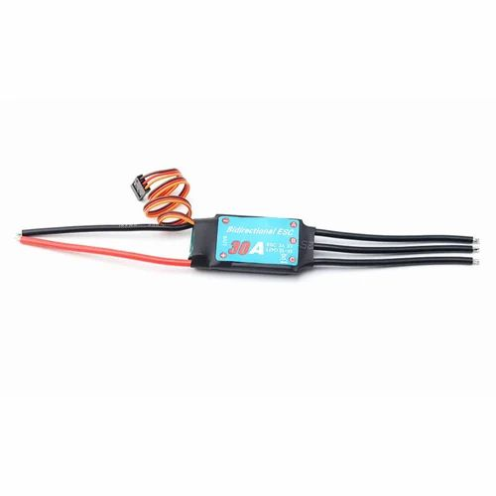

Figure 15 ESC

Specifications

* Continuous Current: 30A
* Burst Current: Up to 40A (for short bursts, such as during sudden acceleration or high-load conditions)
* Input Voltage: 2-4S LiPo (7.4V to 14.8V)
* UBEC Output: 5V, 2A (provides regulated power to the receiver, servos, and other auxiliary electronics)
* Motor Compatibility: Sensor less brushless motors (bidirectional control for both forward and reverse operation)
* Signal Protocol: Standard PWM (Pulse Width Modulation) for motor control

# GPS SENSOR

Table 8 Specifications of GPS Sensor

|  |  |
| --- | --- |
| Receiver Type | 50 channels, GPS L1(1575.42Mhz) |
| Horizontal Position Accuracy | 2.5m |
| Navigation Update Rate | 1HZ (5Hz maximum) |
| Capture Time | Cool start: 27sHot start: 1s |
| Navigation Sensitivity | -161dBm |
| Communication Protocol | NMEA, UBX Binary, RTCM |
| Serial Baud Rate | 4800-230400 (default 9600) |
| Operating Temperature | -40°C ~ 85°C |
| Operating Voltage | 2.7V ~ 3.6V |
| Operating Current | 45mA |
| TXD/RXD Impedance | 510Ω |

GPS is a system of 30+ navigation satellites orbiting the earth. We know where they are in space because they constantly transmit information about their position and current time to Earth in the form of radio signals. A GPS receiver listens to these signals. Once the receiver calculates its distance from at least three GPS satellites, it can figure out where you are. This process is known as Trilateration.

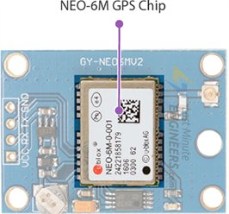**Hardware Overview**

Figure 16 NEO-6M Module

NEO-6M GPS Chip

At the heart of the module is a GPS chip from U-blox – NEO-6M. The chip measures less than a postage stamp but packs a surprising amount of features into its tiny frame.

It can track up to 22 satellites over 50 channels and achieve the industry’s highest level of tracking sensitivity i.e. -161 dB, while consuming only 45 mA current.

Unlike other GPS modules, it can perform 5 location updates in a second with 2.5m horizontal position accuracy. The U-blox 6 positioning engine also has a Time-To-First-Fix (TTFF) of less than 1 second

The required data pins of the NEO-6M GPS chip are broken out to a 0.1″ pitch headers. It contains the pins needed for communication with the microcontroller over the UART. The module supports baud rates from 4800bps to 230400bps with a default baud of 9600.

Position Fix LED Indicator

There is an LED on the NEO-6M GPS module that indicates the status of the ‘Position Fix’. It will blink at different rates depending on which state it is in:

* 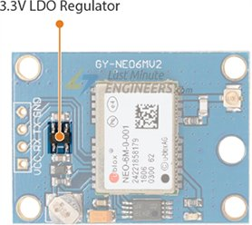No blinking – it is searching for satellites.

Figure 17 Regulator on GPS

* Blink every 1s – Position Fix is found (the module can see enough satellites).

NEO-6M GPS Module Pinout

The NEO-6M GPS module has a total of 4 pins that connect it to the outside world. The connections are as follows:



Figure 18 PINOUT of GPS

GND is the ground pin and needs to be connected to the GND pin on the Arduino.

TxD (Transmitter) pin is used for serial communication.

RxD (Receiver) pin is used for serial communication.

VCC supplies power to the module. You can connect it directly to the 5V pin on the Arduino.

# BLDC MOTOR

**A2212 1400KV BLDC Brushless Motor:**

Figure 19 BLDC Motor

A2212 BLDC Motor is a 3-phase out-runner type popular BLDC motor commonly used in Drones and other multirotor applications. The motor is rated for 1400KV and has an efficiency of 80%. The A2212 motor requires an ESC (Electronic speed controller) to control its speed. The motor can be easily be controlled with our 30A ESC

* ESC Specifications: 18A (min) / 30A (recommended)
* No Load Current: 500mA @10V
* Nominal Current: 12A/60s
* No. of Cells: 2S or 3S Li-Po

Table 9 BLDC Specifications

|  |  |
| --- | --- |
| Motor | BLDC Brushless Motor |
| Model | A2212 |
| Kv | 1400 |
| Stator diameter | 22mm |
| Stator length | 13mm |
| Stator arms | 12mm |
| Magnet Poles | 12 |
| Rotor Diameter | 28mm |
| Shaft Diameter | 3.17mm |
| Weight | 50 grams |

Propellors:

For propulsion of the boat, we have used two A2212 1400KV BLDC Brushless Motors which is coupled to a 200mm Drive Shaft with 150mm Sleeve and 3-Vanes Propeller CCW.

# LI-PO BATTERY

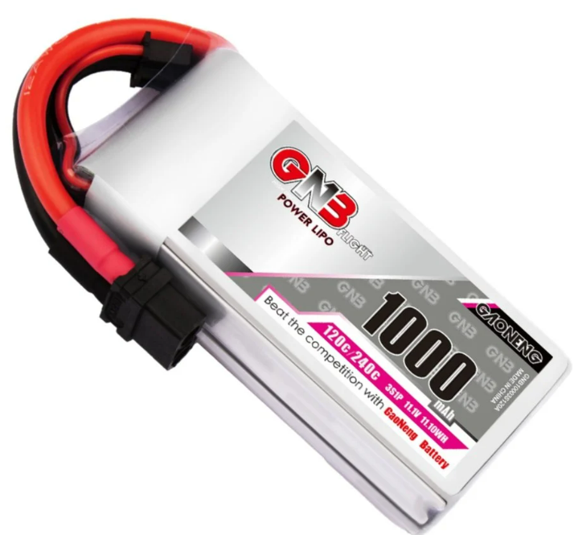

Figure 20 Li-PO Battery

A 12V lithium polymer (LiPo) battery is a type of rechargeable battery commonly used in various electronic devices, including remote-controlled vehicles, drones, portable electronics, and even some electric vehicles. The battery is 120 c rated with burst of 240 and 1000mAh.

Table 10 Battery Specifications

|  |  |
| --- | --- |
| Model No. | GNB10003S120A |
| Capacity | 1000mAh |
| Configuration | 3S1P |
| Nominal Voltage | 11.1V |
| Dimension | 22*34*73mm Appr. |
| Weight | 110g (+/-2g) |
| Max cont. discharge (C-rate/current) | 120C |
| Max Burst  (C-rate/current) | 240C |
| Charge Connector | XH-JST 4P |
| Discharge Connector | XT60 or other |
| Working Temperature Charge | 0~45°C |
| Working Temperature Discharge | (-20~60°C) |
| Working Humility | 65%RH +/-20% |
| Storage Temperature | (25~27°C) |
| Storage Humility | 65%RH +/-20% |
| Life Cycle | 300+ times |

# XT CONNECTOR

# 

Figure 21 XT Connector

Table 11 Specifications of XT Connector

|  |  |
| --- | --- |
| Brand | Amass |
| Gender: | Female/Male |
| Operating Voltage (VDC): | 500 |
| Current Handle Capacity (A) | 60 |
| No. of Contact Points | 2 |
| Connector Type | XT60H |
| Contact Material | Brass |
| Contact Plating | Gold flash |
| Metal Connector Size (mm) | 4.5 |
| Color: | Yellow-Gray |
| Weight (g): | 8 |
| Operating Temperature (˚C): | -20 to 120 |
| Flammability Rating | UL94V-0 |
| Allowed Wire Size (AWG): | 14 ~ 12 |
| Shipping Weight | 0.02 kg |
| Shipping Dimensions | 8 × 6 × 2 cm |

# SCREW PIN TERMINAL

# XY302 3 Pin Screw Terminal Block Connector – 3.5mm Pitch, is a Xinya XY302 2 pin Screw Terminal. The XY302 Series Screw Terminal comes with a current rating of 10A and can accept a wire of 26-16AWG or 1.0mm². These screw terminals can withstand up to 2000VAC/60s. The Xinya XY302 Series Screw Terminals come with such a locking mechanism that it can be connected with either a 2 or 3-pin XY302 Series terminal to make up any pin screw terminals.

Table 12 Specification of Screw Pin Terminal

Figure 22 Screw Pin Terminal

|  |  |
| --- | --- |
| Model | XY302 |
| Pin header | Brass Tin plated |
| Termination | Screw |
| Pitch (mm) | 3.5mm |
| Poles | 3 pins |
| Rated Current (A) | 10A @ 150V |
| Housing Material | PA66（UL 94V-0) |
| Mounting Type: | Through Hole 3 |
| Color: | Green |
| Shipping Weight | 0.001 kg |
| Shipping Dimensions | 3 × 3 × 1 cm |

# FLYSKY CONTROLLER

**FlySky FS-i6 2.4G 6CH PPM RC Transmitter With FS-iA6B Receiver:**

In order to achieve semi-autonomous control of vessel, a transmitter is one of the most important components. You can’t control Bldc motor without it because it uses radio signals to send commands wirelessly to a Radio Receiver, which is connected to an ESC that is being remotely controlled.

Figure 23 FlySky Controller

This is the FlySky FS-i6 2.4G 6CH PPM RC Transmitter With FS-iA6B Receiver.

This radio is also really practical with a 3-position switch. It has two adjustable knobs for flight modes/ multiple flap positions.

It comes with a dual antenna for excellent reception and interference rejection capabilities.

Each transmitter has a unique ID and so when binding; the receiver remembers this ID and accepts data from that transmitter only. This avoids picking up other transmitter signals and dramatically decreases inference and increases safety.

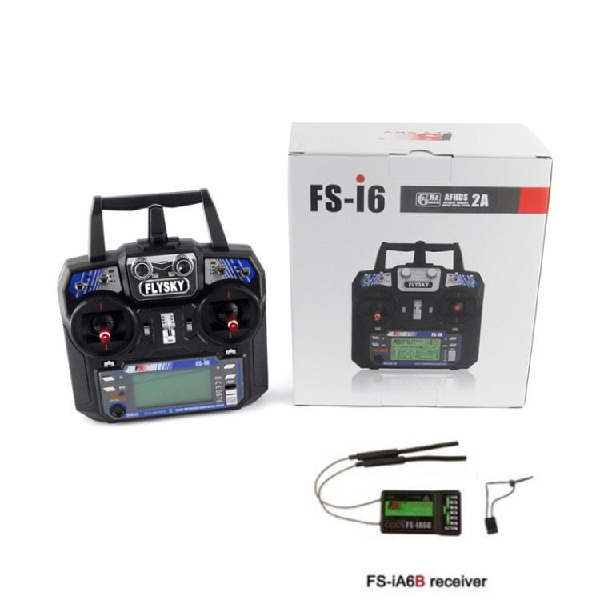**Features:**

1. Entry-level 6 channel 2.4GHz radio with telemetry capability.
2. Dual Rate/Trims/Gear/Flap/Gyro Gain Adjust/Flight Mode/Throttle Hold/Hover Pitch Switches.
3. Easy to use Programming & Navigation Buttons.
4. Supports Heli/Standard Wing/Elevon/V-Tail.
5. 20 Model Memory.
6. 8 Character Model Name.
7. Trainer and charging ports.
8. The backlight LCD screen displays real-time transmitter and receiver voltage.
9. 4 Stick Mode Selectable.
10. Mode 2.
11. It comes with a receiver.

**Flysky Fs-I6 Transmitter Specifications:**

1. Model Type: Glider/Heli/Airplane
2. Band: 142
3. 2.4ghz System: AFHDS 2A and AFHDS
4. Code Type: GFSK
5. DSC Port: PS2;
6. Output: PPM
7. Charger Port: No
8. ANT length: 26mm*2(dual antenna)
9. Online update: Yes
10. Certificate: CE0678, FCC
11. Model Memories: 20
12. Channel Order: Aileron-CH1, Elevator-CH2, Throttle-CH3, Rudder-CH4, Ch 5 & 6 open to assignment to other functions.

**FS-iA6B Receiver Specifications:**

1. Channel: 6.
2. Frequency Range: 2.4055–2.475 GHz.
3. Band Width Number: 140
4. Transmitting Power: ≤ 20 dBm.
5. RF Receiver Sensitivity: 105 dBm.
6. 2.4G Mode: The second generation of an enhanced version of the automatic FM digital system.
7. Encoding: GFSK.
8. Antenna Length : 2 x 26 mm (dual antenna).
9. Input Power : 4.0 – 8.4 VDC (2A).
10. Dimension : 47 x 26.2 x 15 mm
11. Weight: 14.9 gm.
12. Data Acquisition Interface: Yes.
13. Model Type : Airplane / Glider / Helicopter.
14. 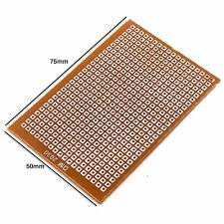Compatible Transmitter: Compatible with FS-i4, FS-i6, FS-i10, FS-GT2E, FS-GT2G.

# ZERO PCB

Figure 24 Zero PCB

Zero PCB is basically a general-purpose printed circuit board (PCB), also known as perfboard or DOT PCB. It is a thin rigid copper sheet with holes pre-drilled at standard intervals across a grid with 2.54mm (0.1-inch) spacing between holes. Each hole is encircled by a round or square copper pad so that component lead can be inserted into the hole and soldered around the pad without short-circuiting the nearby pads and other leads. For connecting the lead of component with another lead, solder these together or join these using a suitable conducting wire.

## Specification

1. Dimension: **50 × 75mm**/**5 x 7.5cm/2×3 inch**
2. Quantity: 1 PCS
3. Copper Thickness 1-4 OZ
4. Board Thickness 0.7-1.2mm
5. Min. Hole Size 0.3mm
6. PCB color: Brown

# JUMPER CABLES

Figure 25 Jumper Cables

# These Female to Male Jumper Wires is very handy for making wire harnesses or jumpering between headers on PCB's. These jumper wires come in a 'strip of 40 (4 pieces of each of ten colors). The sockets on either end have 0.1" spacing end and fit cleanly next to each other on standard-pitch 0.1" (2.54mm) header. They are in a 'ribbon strip' instead of individual wires and can always be pulled to make individual jumpers, or keep them together to make neatly organized wire harnesses. For best results, when plugging these in a line, have the sides with the 'silver latch bit' sticking out since that side is a tiny bit wider than 0.1"

# BERG STRIP

# 

Figure 26 Berg Strip

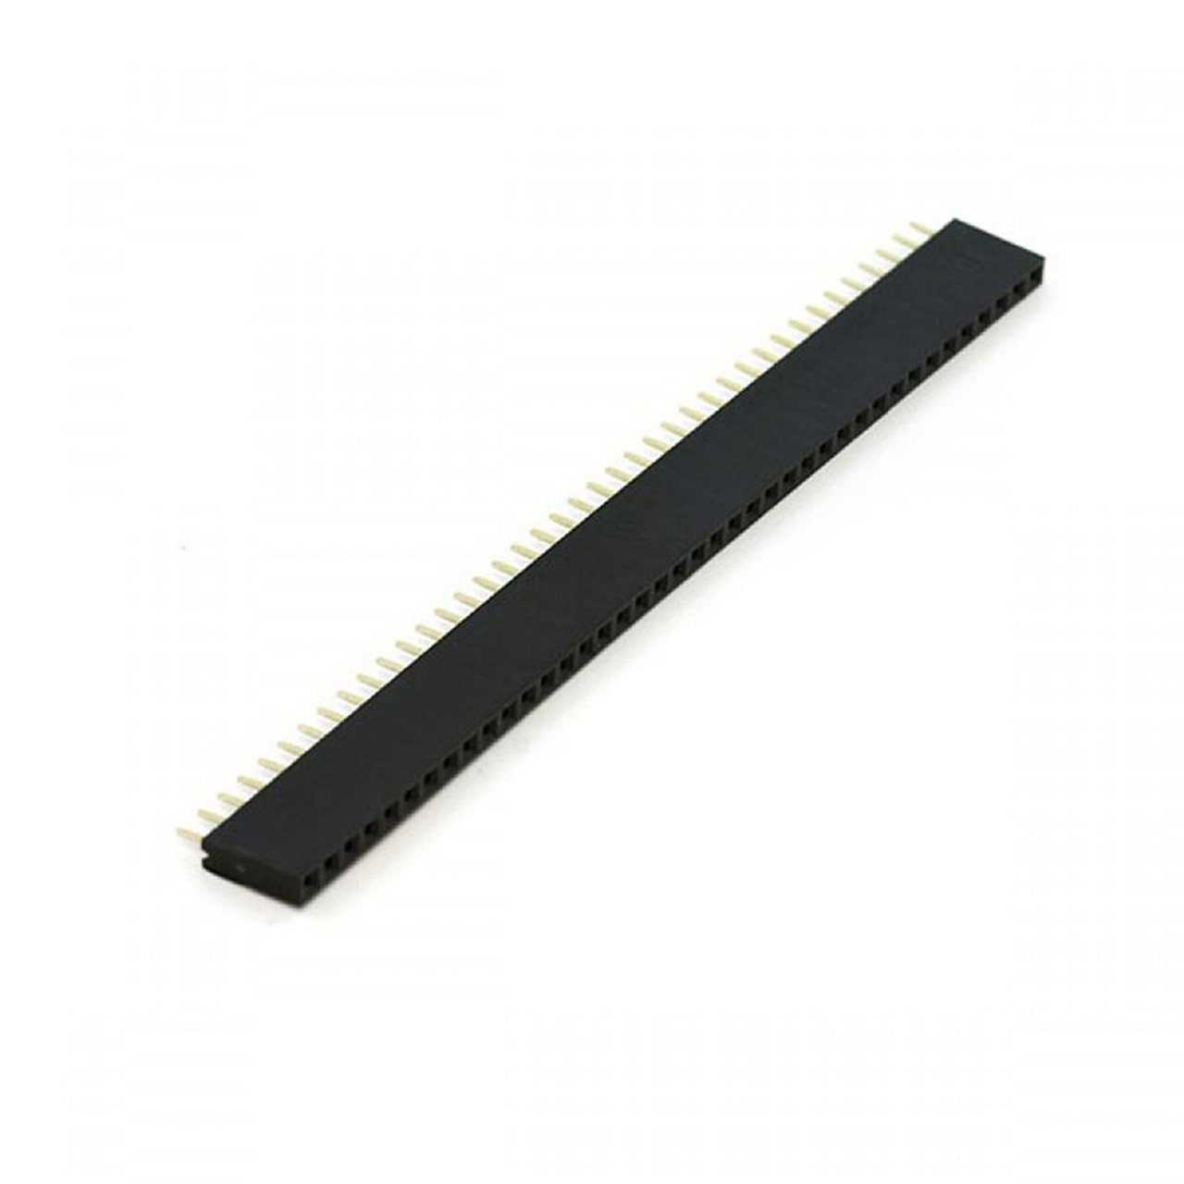Table 13 Berg Strip Specification

|  |  |
| --- | --- |
| Connector | Header Strip |
| Gender: | Female |
| Mounting Type: | Through Hole |
| Pin Spacing (mm) | 2.54 |
| Contact Material | Phosphor Bronze |
| Contact Resistance | 20mΩ |
| Insulation Material | PBT UL 94V-0 |
| Insulation Resistance (MOhm) | ≥1000 |
| Length (mm): | 103 |
| Width (mm): | 2.4 |
| Height (mm): | 8 |
| Weight (g): | 1 (approx.) (each) |
| Shipping Weight | 0.03 kg |

# TOGGLE SWITCH

Figure 27 Toggle Switch

Table 14 Switch Specifications

|  |  |
| --- | --- |
| Rated Voltage (V) | 120V AC |
| Rated Current (A) | 5 |
| Contact Resistance | 100mΩ (Max.) |
| Insulation Resistance (MOhm) | 1000 |
| Mech. Electrical Lifecycle | ≈ 100,000 |
| Operating Temperature (˚C): | -30 to 85 |
| Switch Type | SPDT |
| Length (mm): | 13 |
| Width (mm): | 7 |
| Height (mm): | 10 |
| Weight (g): | 4 |
| Shipping Weight | 0.005 kg |
| Shipping Dimensions | 4 × 7 × 1 cm |

# This heavy-duty single-pole, double-throw (SPDT) toggle switch makes a great power switch or state selector for user interfaces. It is rated for 5 A at 125 VAC and 2 A at 250 VAC.

# DESIGN SPECIFICATIONS

### ****Autodesk Fusion 360 Overview****

Autodesk Fusion 360 is a powerful, cloud-based 3D CAD (Computer-Aided Design), CAM (Computer-Aided Manufacturing), and CAE (Computer-Aided Engineering) software. It enables engineers and designers to create precise and detailed 3D models, offering tools for simulation, rendering, and manufacturing. Fusion 360 integrates all these functions into a unified platform, streamlining workflows and promoting collaboration.

### ****Features of Autodesk Fusion 360 for 3D Modeling****

1. **Parametric Modeling**: Fusion 360 allows parametric modeling, where designs are driven by parameters like dimensions and relationships between features. This makes it easy to modify and update parts as needed.
2. **Assembly Modeling**: The software provides an environment to assemble multiple components, allowing you to test how parts interact and fit together, essential for designing complex systems like water monitoring vessels.
3. **Rendering and Visualization**: With Fusion 360, you can apply realistic textures, materials, and lighting to your models, generating high-quality images that make it easier to visualize the final product.
4. **Simulation**: Fusion 360 includes simulation tools that analyze your design's structural integrity, making it easier to evaluate if it can withstand real-world conditions.

Figure 28 Autodesk Fusion360

1. **Manufacturing Support**: The CAM features in Fusion 360 help generate toolpaths for CNC machines, allowing seamless production of parts directly from the 3D model.

**Steps to Create 3D Models in Autodesk Fusion 360**

1. **Create a New Sketch**:
   * Open Fusion 360 and start a new design file.
   * Choose a plane (e.g., XY, YZ, or XZ) to create a 2D sketch. This plane serves as the base for your 3D model.
   * Using tools like lines, circles, rectangles, and arcs, sketch the outline of the part you want to model.
2. **Define Dimensions and Constraints**:
   * Use dimension tools to set the size of each feature, ensuring precision and accuracy.
   * Apply constraints to control relationships between sketch elements, such as keeping lines parallel or equal, which simplifies editing.
3. **Extrude or Revolve the Sketch**:
   * After finalizing the 2D sketch, use the "Extrude" or "Revolve" tool to convert it into a 3D shape.
   * Extrusion adds depth to a shape by pulling it along a defined path, while Revolve rotates it around an axis, useful for symmetrical parts like wheels.
4. **Add Additional Features**:
   * Use tools like "Fillet" for rounded edges, "Chamfer" for angled edges, and "Shell" to hollow out parts.
   * Use "Cut" or "Join" operations to modify your model by combining or subtracting parts of it as needed.
5. **Assemble Components**:
   * If your design has multiple parts, create each part separately and then combine them in an assembly.
   * Use "Joints" to simulate the movement and interaction between parts, ensuring that each component fits and functions as intended.
6. **Apply Materials and Appearance**:
   * Assign realistic materials to each component, which can affect weight and strength calculations.
   * Customize the appearance to improve the model’s realism, making it easier to visualize the final product.
7. **Simulation and Analysis**:
   * Run simulations on load-bearing components to test stress and durability.
   * This helps identify any weaknesses in the design and allows for necessary adjustments before physical prototyping.
8. **Rendering and Exporting**:
   * Use Fusion 360’s rendering tools to create realistic images of your design.
   * 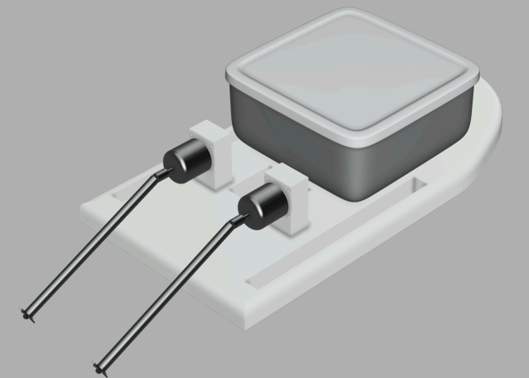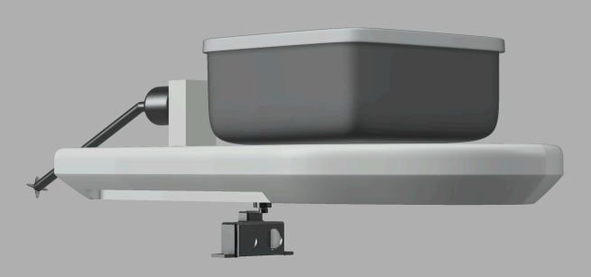Export your model in formats like STL or OBJ for 3D printing or further processing in other software.

Figure 30 Top View of 3d model

Figure 29 Side View of 3d model

**Chapter 4 METHODOLOGY**

Current methods for using unmanned vessels to monitor water pollution include a number of crucial steps, all of which add to a system that collects data effectively and efficiently. From little ponds to huge lakes, these technologies offer a trustworthy way to evaluate the water quality in various bodies of water.

The first step in the process is choosing the right hardware, which is essential to ensuring the vessel can function well under a range of circumstances. In order to detect and steer clear of impediments like floating plastic garbage or submerged solid trash, the A02YYUW ultrasonic sensor was selected. In addition, a number of sensors are employed to detect the water's temperature, turbidity, pH, and total dissolved solids (TDS). When evaluating the safety and health of water ecosystems, these metrics are crucial.

The Arduino Nano RP2040 microcontroller was chosen for this system because of its capacity to process and transmit data wirelessly. The vessel can collect data from the several sensors and transmit it to a central monitoring system thanks to this microcontroller. Wireless communication is particularly crucial since it allows for remote vessel monitoring and control without requiring face-to-face interaction. This capability is especially helpful for getting to places that are difficult to reach, like big lakes or ponds, where it would be difficult to set up manual sample equipment.

Another essential element of this technology is the vessel's mobility. An electronic speed controller (ESC) governs the brushless DC (BLDC) motor that is part of it. The sailboat can navigate the water with ease and efficiency because to its configuration. Because of their great efficiency, dependability, and little maintenance needs, BLDC motors are the best choice for extended operations in a variety of aquatic conditions. Even when there are fluctuating water currents, the motor and ESC make sure the boat can keep a steady pace.

The sensors are calibrated and integrated into the system after the hardware has been installed. In order to guarantee accurate and trustworthy results from water quality indicators, calibration is necessary. In accordance with World Health Organization (WHO) guidelines, this procedure guarantees that the sensor data can be utilized with confidence to evaluate the water's quality. When environmental conditions change, real-time calibration techniques enable modifications to be performed, ensuring data accuracy throughout the vessel's operation.

Using Internet of Things protocols, the ship sends the sensor data to the Arduino Cloud. Users can track water quality indicators remotely using desktop or mobile devices thanks to this data transfer procedure, which eliminates the necessity for in-person attendance at the water body. This wireless capacity is essential for making decisions in real time and enables stakeholders, like research teams or environmental authorities, to track changes in water quality over time. A thorough picture of the state of the water can be obtained by storing and analyzing data via cloud connection.

Another crucial factor to take into account is the vessel's actual design. Because of its strong construction and low weight, the boat can withstand a variety of water conditions, including still lakes and places with gentle currents or waves. The sturdy construction guarantees that the sensors and electronic parts are kept safely inside, guarding against harm from spills and debris. By guaranteeing the equipment's long-term functioning, this protection lowers the frequency of maintenance requirements and increases the vessel's operational lifespan.

An essential component of obstacle avoidance is the ultrasonic sensor. It helps the boat avoid obstructions like logs, rocks, or floating debris by using sound waves to identify objects in the water. This function guarantees that the ship may move across various environments without being caught or damaged, enabling continuous data collection. Additionally, the vessel can operate in environments that would be dangerous for human operators thanks to the obstacle detecting system.

With a focus on automation, the entire system is made to be operated remotely. Compared to conventional manual sampling techniques, this enables the vessel to independently collect data on water quality from several locations within a body of water, covering a larger region. It is possible to configure the ship to follow particular routes or concentrate on regions where pollution levels are thought to be greater. Because of this flexibility, data may be collected more precisely, which facilitates the identification of trends and sources of contamination.

By eliminating the need for human interaction, this automated system improves the efficiency and economy of the monitoring process. It is especially helpful for big bodies of water, where manual sampling would take a lot of time and effort. The system's scalability allows it to be modified for usage in a variety of water bodies, including big lakes, small local ponds, and, with some modification, estuaries or rivers. Furthermore, it ensures users obtain the most recent data on water contamination levels through continuous data transfer, which is essential for the early identification of environmental problems.

For propulsion, the vessel is powered by two A2212 1400KV BLDC brushless motors, each coupled to a 200mm drive shaft with a 150mm sleeve and a 3-vanes CCW propeller. These BLDC motors are controlled via a 30A Electronic Speed Controller (ESC) and a FlySky controller, allowing for precise manoeuvrability and speed adjustments. This robust propulsion system ensures the vessel can effectively traverse water bodies, collecting data across different locations while avoiding obstacles for optimal data accuracy and operational efficiency.

The unmanned vessel is equipped with a Neo 6M GPS chip which is interfaced with ESP8266 board, which plays a crucial role in navigation and location tracking. This GPS module allows the vessel to autonomously navigate across water bodies while providing precise location data, which enhances the accuracy of data collection by enabling tracking of the specific areas monitored.

**Chapter 5 IMPLEMENTATION**

## Hardware Assembly

**Microcontroller Selection**

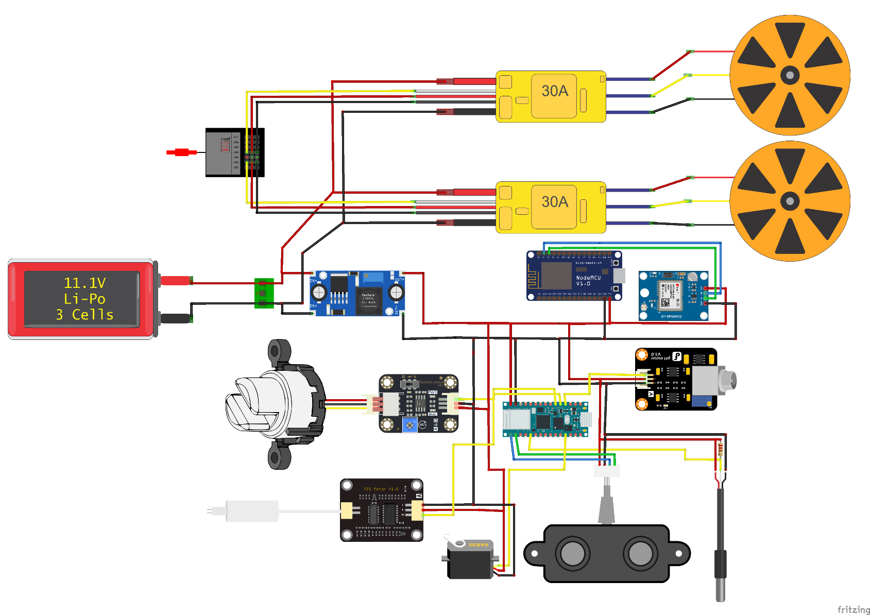The Arduino Nano RP2040 Connect was selected because of its small form factor, computing performance, and Internet of Things functionality to easily send data to the Arduino Cloud.

Figure 31 Connection Diagram of Project

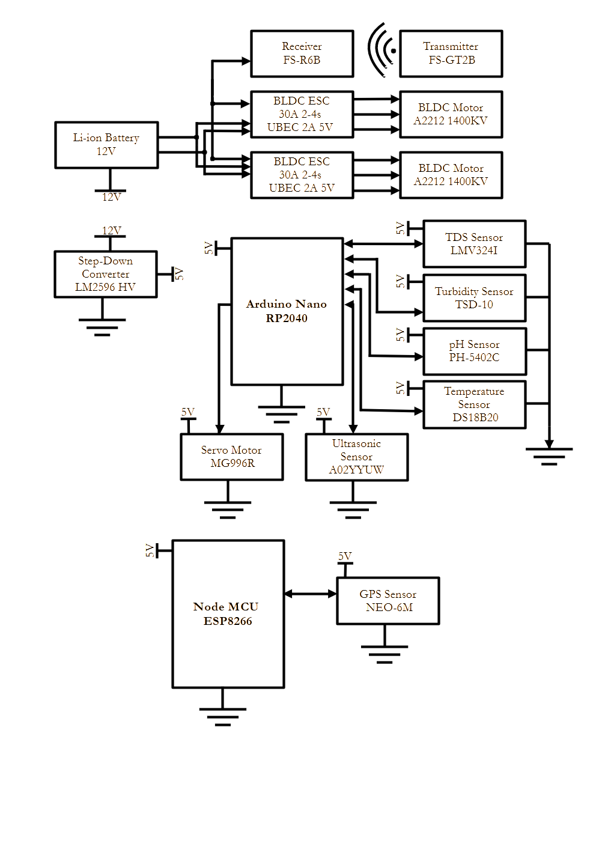

Figure 32 Block Diagram of Project

**Sensor Integration**

Sensors were carefully selected and connected to ensure accurate measurements of critical water quality parameters:

* Temperature Sensor (DS18B20): Connected to digital pin D3.
* Turbidity Sensor: Connected to analog pin A0.
* TDS Sensor: Connected to analog pin A1.
* pH Sensor: Connected to analog pin A2.
* Ultrasonic Sensor (A02YYUW): This is for obstacle detection placed through specific trig and echo pins.
* GPS and Communication Module
* The identified GNSS GPS module of the ESP8266 Wireless WIFI permits transmission of GPS location data thus enhancing the real-time tracking of the vessel. Information collected by the GPS module is transmitted to WEB panel that can be viewed in the cloud.

**Power System Design**

With LiPo battery power, the ship is capable of a long duration of operation as the motors are run through ESC (Electronic Speed Controllers) for efficient utilization of power on water surfaces.

**Motor Assembly**

Two BLDC motors are incorporated in this vessel with respective ESC to drive the vessels. These motors are able to handle all necessary hardware including the GoPro camera, additional sensors and a 750 g permitted payload of a LiPo battery pack.

## Software Implementation

**Controlling through Program in Arduino Nano RP2040 Connect**

Despite not developing the microcontroller per se, programming was done using the Arduino Integrated Development Environment or IDE incorporating code for acquiring sensor data and GPS, and for sending all collected data to the cloud.

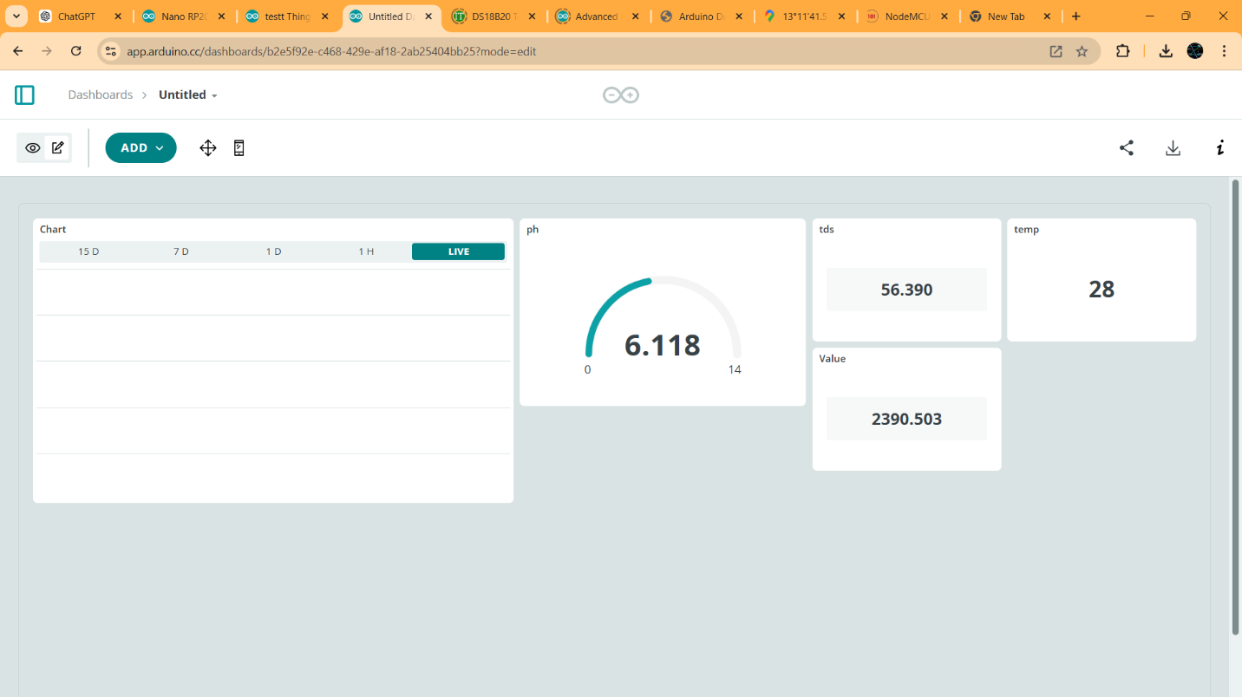

Figure 33 Arduino Cloud Dashboard

We also need to understand more about Sensor Calibration, as well as Data Filtering.

Each sensor was then calibrated in order to obtain the most accurate data as possible. This included:

* The second efficient modification is adjusting the reference voltage for analog sensors.
* Using TDS and turbidity control to define the regular conditions and conditions that require treatment from the wastewater.
* Accomplishment of eradicating irrelevant or sources of noise when attempting measurements that require precision.
* IoT and Cloud Integration

Information from the sensors and GPS is then sent wirelessly through Wi-Fi to Arduino Cloud using the ESP8266 module. The cloud setup includes:

* Cloud Dashboard: Data interface of the current values of the pH, turbidity, TDS and temperature of the water.
* GPS Mapping: The vessel location is illustrated within the map in the dashboard, enabling the users to track the pollution level in the various areas.
* Threshold Alerts: Scheduled to alert ground teams when concentration levels of pollutants are high beyond recommended tolerances.

**Remote Control Setup**

A FlySky remote control system can also be operated in such a way that automatic control can be overridden for semi-automatic control. This is important most especially in harbors or for changing direction or course.

## Testing

Figure 34 Code Testing

System tests for the unmanned vessel included; calibration of each specific sensor, interconnecting tests where each unit was connected and tested individually and finally the field tests across some of the water bodies to facilitate testing of precise readings as well as standard performance.

* **Temperature Sensor (DS18B20)**
  + Calibration: The DS18B20 sensor was first oriented by comparing the water samples taken at various temperatures and a digital thermometer.
  + Accuracy Check: The readings obtained were found to be within ±0.5 % proving the accuracy needed for environmental monitoring.
  + Field Test: The sensor was capable of capturing temperatures in different bodies of water depending on the ambient temperature and water temperature.
* **Turbidity Sensor**
  + Calibration: Standardized with solutions with specific turbidity amounts in NTU units, setting the analog reading to standardized values.
  + Accuracy Check: Verified in testing where the output of the sensors was checked to a turbidimeter for comparison.
  + Test: In field trials, the sensor successfully detected variations in water turbidity arising from particulate and organic matter load.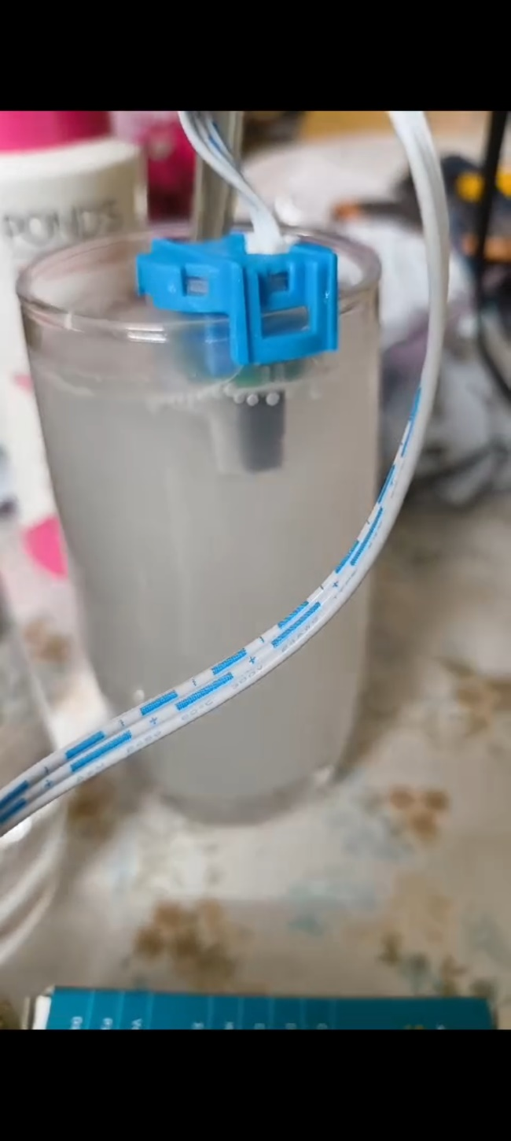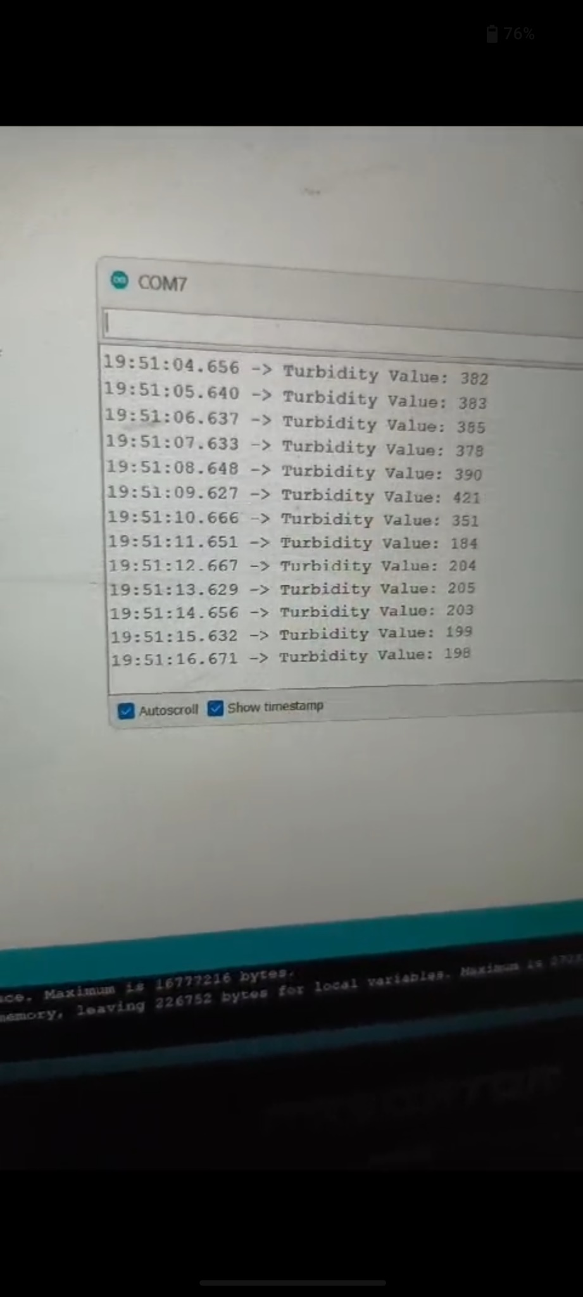

Figure 35 Turbidity Testing

* **TDS Sensor**
  + Calibration: Hence; TDS sensor was configured with solutions with different salinity levels to assure the unit range of the probe.
  + Accuracy Check: Values were compared with TDS meter of a laboratory to know the precision of the sensor.
  + Field Test: They also demonstrated a responsive measurement of dissolved solids with particular application in prawn farms where nutrient washings affected TDS measurements.

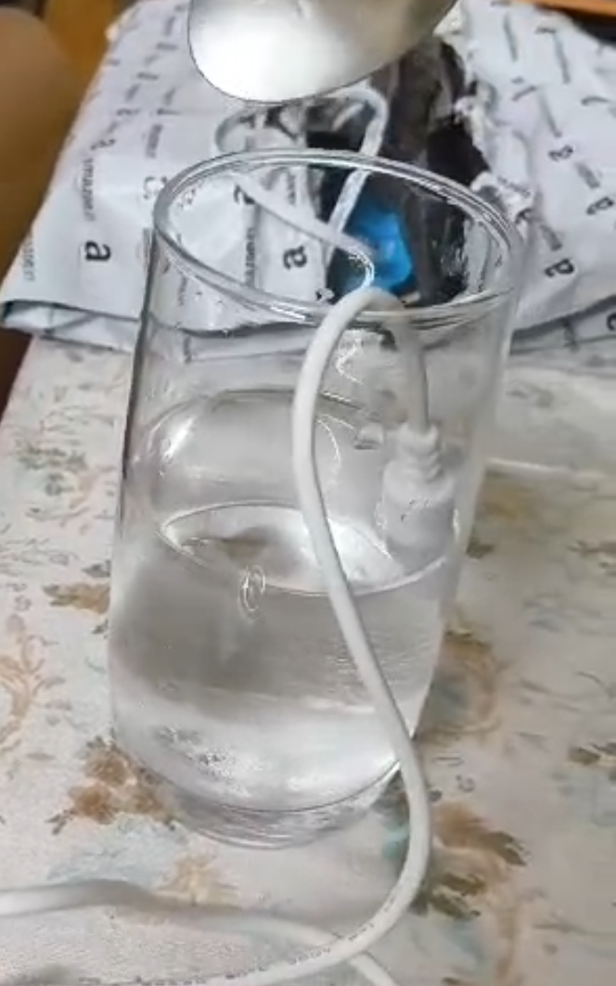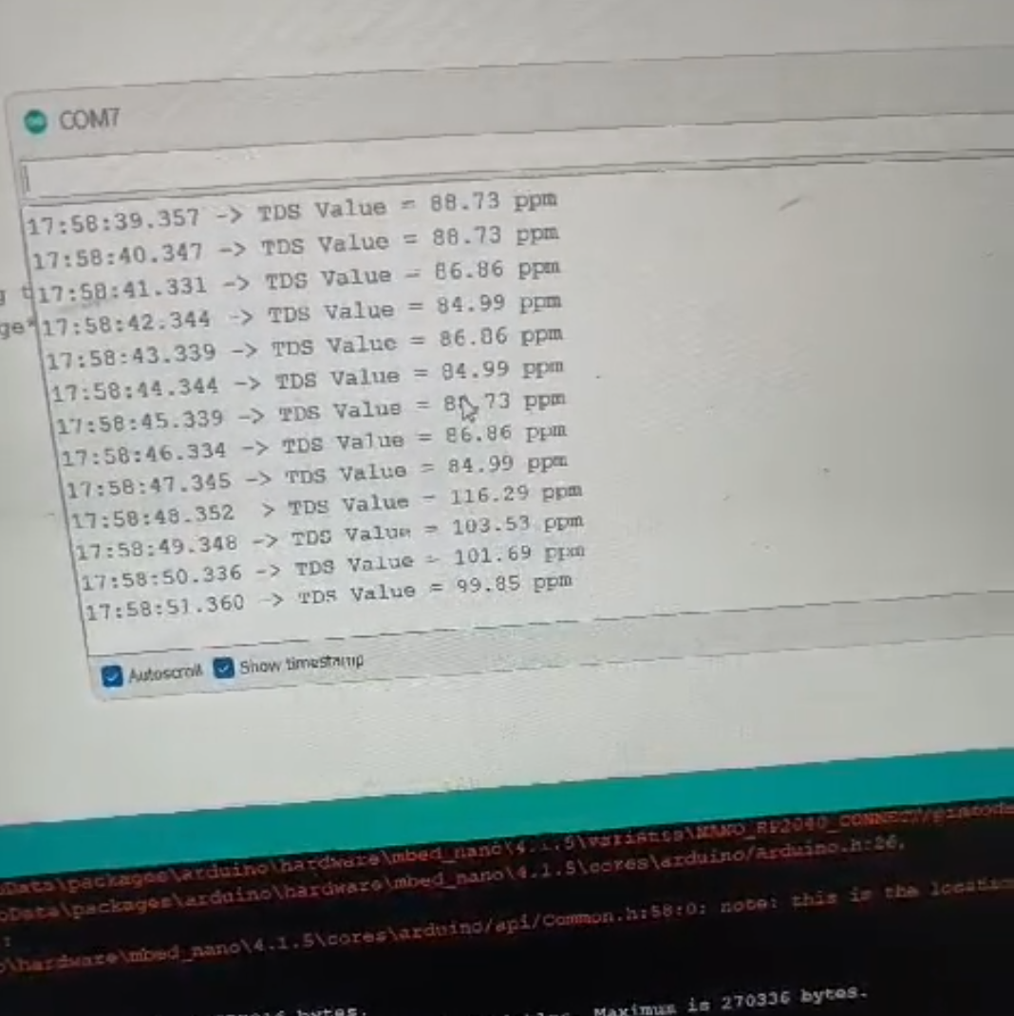

Figure 36 TDS Testing

* **pH Sensor**
  + Calibration: Standardized with buffer solutions comprising of pH 4, 7 and 10 to obtain initial and most appropriate zero-point values.
  + Accuracy Check: A calibration done with the help of a pH meter while ensuring the results read with a selective discrepancy not more than 0.1 pH units.
  + Field Test: In field conditions, the sensor successfully quantified changes in pH, for instance, in the Sita River, which had low pH level caused by organic load.

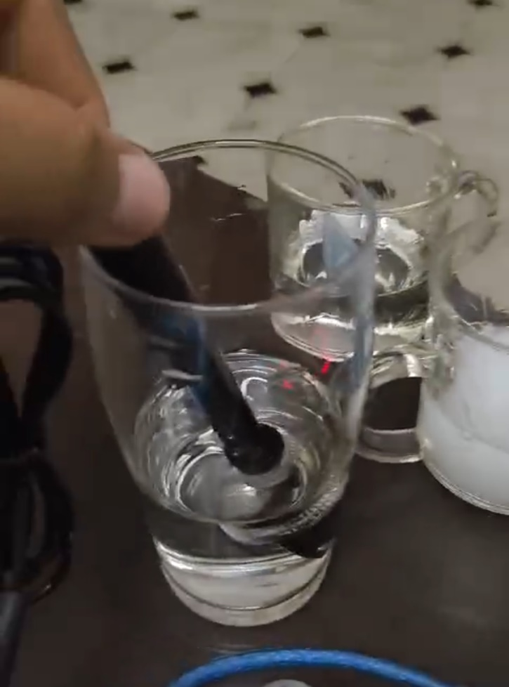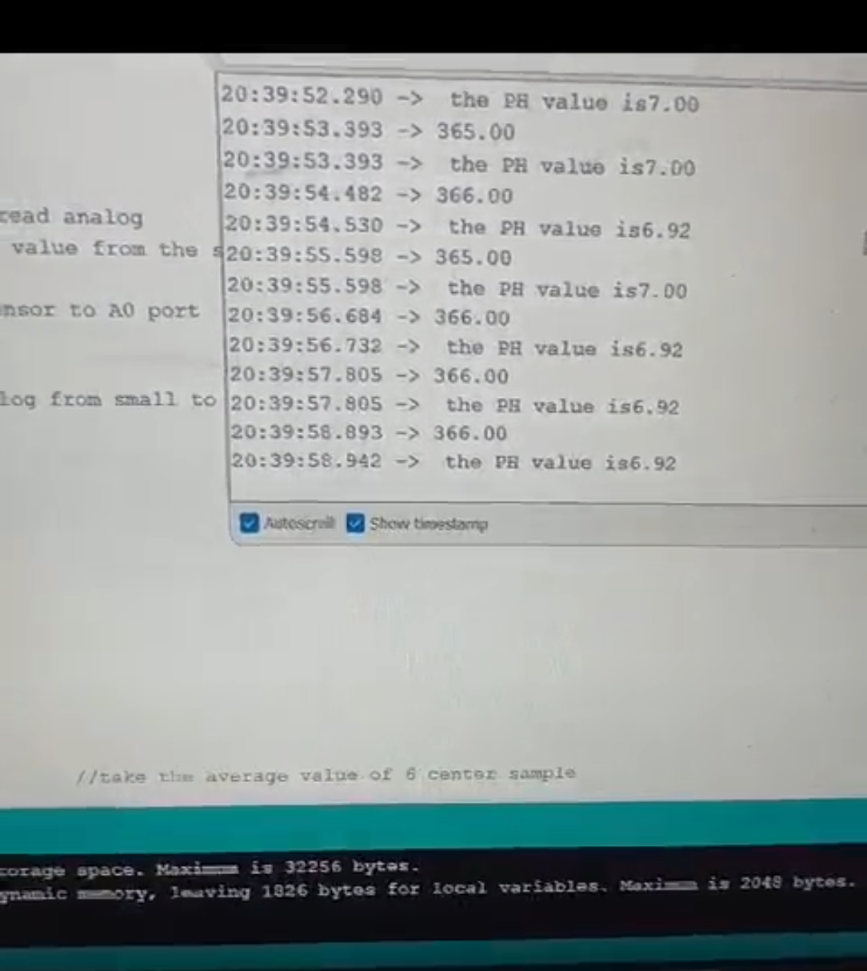

Figure 37 PH Testing

* **Ultrasonic Sensor (A02YYUW)**
  + 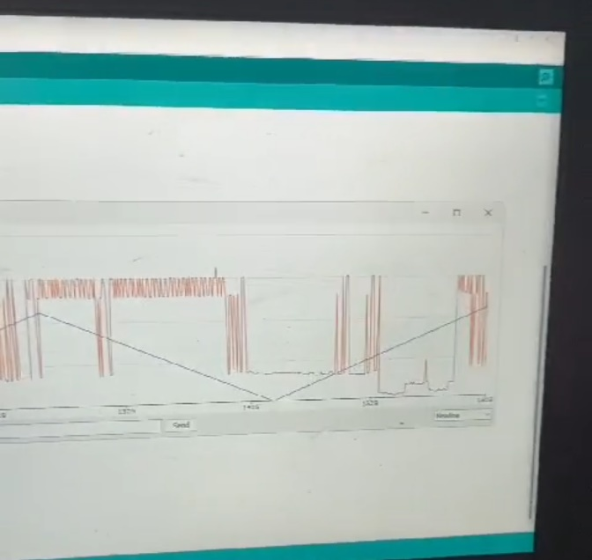Calibration: As mentioned in the testing process, different distance thresholds for the obstacle detection were introduced.

Figure 38 Ultrasonic Testing

* + Accuracy Check: Compared to observing distances and position of waste left behind to be normally estimated by the trainer on the field.
  + Field Test: Demonstrated a strong performance in identifying floating debris and obstacles in supporting waste detection of the vessel.
* **GPS Module**
  + Testing: Held outdoors to ensure proper mounting and connection of the ESP8266 electronics for the purpose of data relay.
  + Field Test: The GPS actively tracked the location in the selected test sites with data transferred to the Arduino Cloud for display purposes.
* **Integrated System Testing**
  + Cloud Data Transmission: Each sensor's data was successfully transmitted via the ESP8266 to the Arduino Cloud, displaying real-time data on the dashboard.
  + Response Time: The delay between sensor reading and cloud visualization averaged less than 5 seconds, within acceptable limits for real-time monitoring.
  + 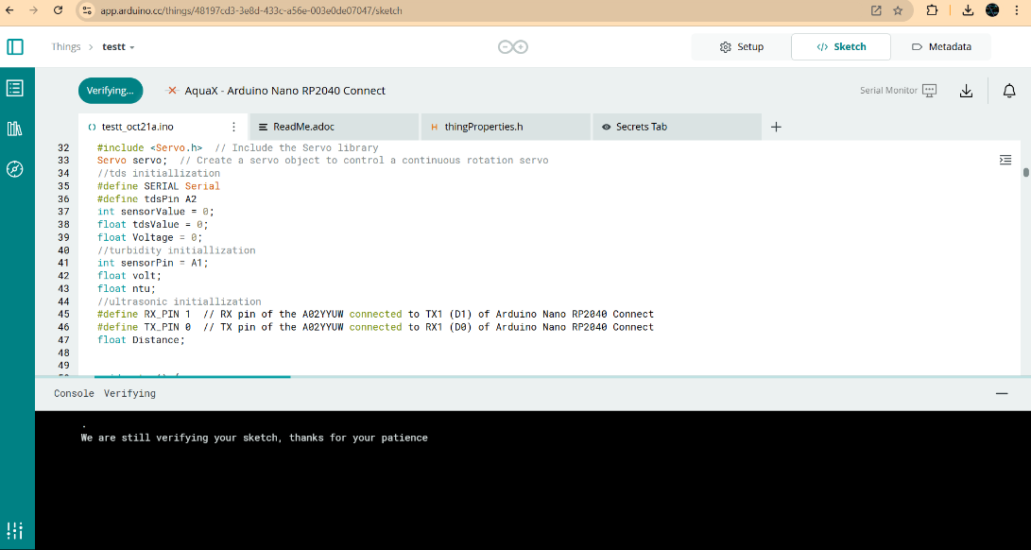Remote Control: FlySky remote control testing ensured that the vessel could be manually navigated when necessary, responding accurately to directional changes.

Figure 39 Cloud Compiler

## Deployment

* **Prawn Farm (Kundapura)**
  + Objective: Determining astounding nutrient density and unanticipated wastage amounts.
  + Findings: High TDS and turbidity values supported nutrient-rich status succeeding the system’s capability of detecting low-quality water areas.
* **Sita River (Barkur)**
  + Objective: Maintain turbidity and pH which changes season and environmental conditions.
  + Findings: The observations made by the vessel included fluctuations in turbidity and pH levels, which justified the proposed seasonality of the methods for rivers with contaminated organics.
* **Rainwater-Fed Lake (Karkala)**
  + Objective: Use minimal invasion to lay data foundation in a low acuity environment.
  + Findings: Other parameters were constant correlating with natural water quality, suggesting that the vessel may accurately pinpoint areas of low contamination.
* **Performance Summary**
  + Data Accuracy: Real-world data was in parallel with lab data ensuring the reliability of a sensor.
  + Autonomy: The vessel ran half autonomously, and was utilized for testing routes while transmitting data.
  + System Reliability: Due to compactness of the structure and water proof housing, the vessel was able directly expose the vessel to different water conditions and no harm was seen on the sensors.

## Algorithm

**1. Initialization**

* **pH Sensor**: Define the reference voltage Vref and initialize variables for pH calculation.
* **Servo Motor**: Include the Servo library and create a servo object for continuous rotation control.
* **TDS Sensor**: Define the analog pin for TDS, and initialize variables for sensor readings and voltage calculations.
* **Temperature Sensor**: Include OneWire and DallasTemperature libraries. Define and set up the data pin for communication.
* **Turbidity Sensor**: Define the analog pin and initialize variables for voltage and NTU (Nephelometric Turbidity Units).
* **Ultrasonic Sensor**: Define TX and RX pins for serial communication with the A02YYUW ultrasonic sensor.

**2. Setup Configuration** *(Function: setup())*

* **Begin Serial Communication**:
  + Initialize Serial at 115200 baud for general monitoring.
  + Initialize Serial1 at 9600 baud for the ultrasonic sensor.
* **Sensor and Actuator Setup**:
  + Set A0 as input for pH sensor.
  + Attach servo motor to digital pin 9.
  + Start the DallasTemperature library for the temperature sensor.

**3. Main Loop** *(Function: loop())*

* **pH Sensor Measurement**:
  + Take 10 samples from analog pin A0 to average out noise.
  + Sort the values, and calculate the average of the 6 central values.
  + Convert the average value to pH using the formula based on calibration and print the result.( phValue = 7 - 1000 * (sensorValue - 541) * Vref / 59.16 / 1023;)
* **Servo Motor Control**:
  + Rotate the servo to the left, stop, then rotate right, and stop. Repeat these motions periodically for scanning.
* **TDS Sensor Measurement**:
  + Read analog input from tdsPin and convert it to voltage.
  + Calculate TDS using a polynomial equation based on the voltage reading. ( tdsValue=(133.42*Voltage*Voltage*Voltage - 255.86*Voltage*Voltage + 857.39*Voltage)*0.5;)
  + Print TDS value in ppm (parts per million).
* **Temperature Measurement**:
  + Request temperature readings from the sensor. ( sensors.getTempCByIndex(0))
  + Print temperature in both Celsius and Fahrenheit.
* **Turbidity Measurement**:
  + Read multiple voltage values from the turbidity sensor and calculate an average.
  + Convert the voltage to NTU based on a piecewise function.( ntu = -1120.4 * sq(volt) + 5742.3 * volt - 4353.8;))
  + Print NTU value indicating water clarity.
* **Ultrasonic Sensor Distance Measurement**:
  + Read serial data from the ultrasonic sensor.
  + If a valid data frame is received, calculate and display the distance in mm. ( distance = (data[1] << 8) | data[2];))
  + Indicate "Out of range" if the distance exceeds the sensor range.

**4. Servo Motor Control Functions**

* **Rotate Left** *(Function: left())*
  + Rotate the servo counterclockwise at maximum speed.
* **Rotate Right** *(Function: right())*
  + Rotate the servo clockwise at maximum speed.
* **Stop Servo** *(Function: stopServo())*
  + Stop the servo by setting it to the neutral position.

**5. Calibration of Sensors**

* pH Sensor (e.g., Analog pH Sensor)

Procedure: Use of buffer solutions with known pH values (for instance pH 4, pH 7, and pH 10) to calibrate the sensor.

Steps:

* Rinse the sensor with distilled water and dip it into a pH 7 buffer. Note the output of the sensor and make necessary adaptations to its set value to be in accordance to the buffer pH value.
* Continue with pH 4 and pH 10 solutions respectively making corrections if required.
* Adjustment: If needed in your code use offset adjustments or perform adjustments in the hardware in order to proper the expected range of the sensor output to the sensor operating range values for pH.
* Turbidity Sensor

Procedure: Define the turbidity of standards required in calibration and their corresponding reference standards of either 0 NTU clear water or turbid solutions with known NTU values.

Steps:

* Bathe the sensor in distilled water and take some readings using the turbidity sensor to get the baseline output where all readings should equal to 0 NTU.
* Use a turbidity standard or calibrated solution and used for such higher NTU values, correcting code instructions where it is necessary hundred and fifty for values readings in expectable st values.
* Calibration Equation: Any linear or polynomial equations obtained from the calibration should be provided that make sense of the readings of the sensors and converts them to NTU.
* Temperature Sensor (for example DS18B20)

Procedure: Explain how to measure comparison between the DS18B20 sensor readings with that of a standard accurate reference thermometer.

Steps:

* Immerse the sensor in water at a constant temperature using either ice water (0° c) or boiling water (100° c) to create a range for calibration.
* Watch and record the output of the sensor during the exposure to every individual temperature point, correcting it in case any drift against the standard temperature is noted.
* Adjustments for the Code: Specify any offsets that were introduced in the code for deviation of sensors from standard values.
* TDS Sensor

Procedure: TDS sensors frequently need calibration with a standard solution of known TDS or conductivity.

Steps:

* In most cases, the sensor is immersed into a 342-ppm calibration solution, as it is widely accepted as a reference standard.
* Output of the sensor is recorded and adjusted to the desired level.
* GPS Sensor

Testing in a Known Location: Test the GPS module in an area with a known, precisely documented location (like a mapped point on Google Maps).

Steps:

* Take the GPS readings and compare the coordinates with the known values.
* Record any discrepancies to understand the typical error range of your module.
* **Adjustment**: If significant offsets are detected, you may need to consider this error margin in subsequent readings and communicate it in your data.

**Chapter 6 RESULT AND ANALYSIS**

The unmanned water quality monitoring vessel has proven effective across several key dimensions, providing both actionable insights and the groundwork for scalable environmental monitoring.

## Enhanced Data-Driven Insights

1. **Granular Data Collection and Trend Analysis:**

By capturing a range of water quality parameters, the vessel enables trend analysis over time, helping to identify patterns in water pollution. For example, areas with recurring high TDS or turbidity values can be flagged for further investigation, indicating potential sources of contamination such as industrial effluents or agricultural runoff.

1. **Comparative Water Quality Index (WQI) Evaluation:**

The real-time WQI assessment offers a quantitative measure for comparing water quality across various sites. This feature enables the prioritization of clean-up efforts and helps gauge the effectiveness of pollution control interventions over time.

## Technical Performance and Robustness

1. **High-Accuracy Sensors for Comprehensive Monitoring:**

The sensors selected for this vessel, such as the DS18B20 temperature sensor, pH sensor, TDS sensor, and turbidity sensor, are known for reliability and precision. These parameters provide a comprehensive profile of the water body, supporting proactive and accurate pollution assessment.

1. **Durable Design for Varied Water Conditions**:

Designed to operate in different environments—from prawn farms to riverbanks and lakes—the vessel is resilient to moderate physical and environmental stresses. The use of a waterproof housing for the sensors and electronics ensures reliable performance in challenging conditions.

1. **Low-Maintenance, Semi-Autonomous Operation:**

The vessel's semi-autonomous mode reduces the need for continuous human intervention. It can navigate and transmit data without supervision, and the FlySky remote controller allows for manual adjustments when needed, making it practical for extended fieldwork in remote or hard-to-reach locations.

## Environmental and Societal Impact

1. **Improved Aquatic Ecosystem Health:**

By identifying specific pollution sources (such as nutrient runoff in prawn farms or sediment in rivers), the system aids in taking targeted actions that help mitigate environmental impact. This monitoring approach supports the maintenance of balanced ecosystems, helping protect biodiversity in aquatic environments.

1. **Empowering Communities with Real-Time Data Access:**

The cloud integration allows real-time access to water quality data via desktop or mobile, empowering local communities, environmental agencies, and stakeholders to take action. These insights contribute to education and awareness regarding local water quality issues, promoting stewardship of water resources.

1. **Informed Policy and Regulation Support:**

Detailed data from the vessel can be valuable for regulatory bodies aiming to set and enforce water quality standards. With empirical evidence of pollution trends and hotspots, local authorities and environmental bodies can enact stricter regulations or incentivize cleaner practices in vulnerable areas.

## RESULTS

The **Water Quality Monitoring System** effectively assessed multiple water parameters across diverse locations, providing real-time data on environmental health. Below are the summarized observations and results for each monitored site, highlighting specific water quality indicators and conditions:

**Location 1: Prawn Farm**

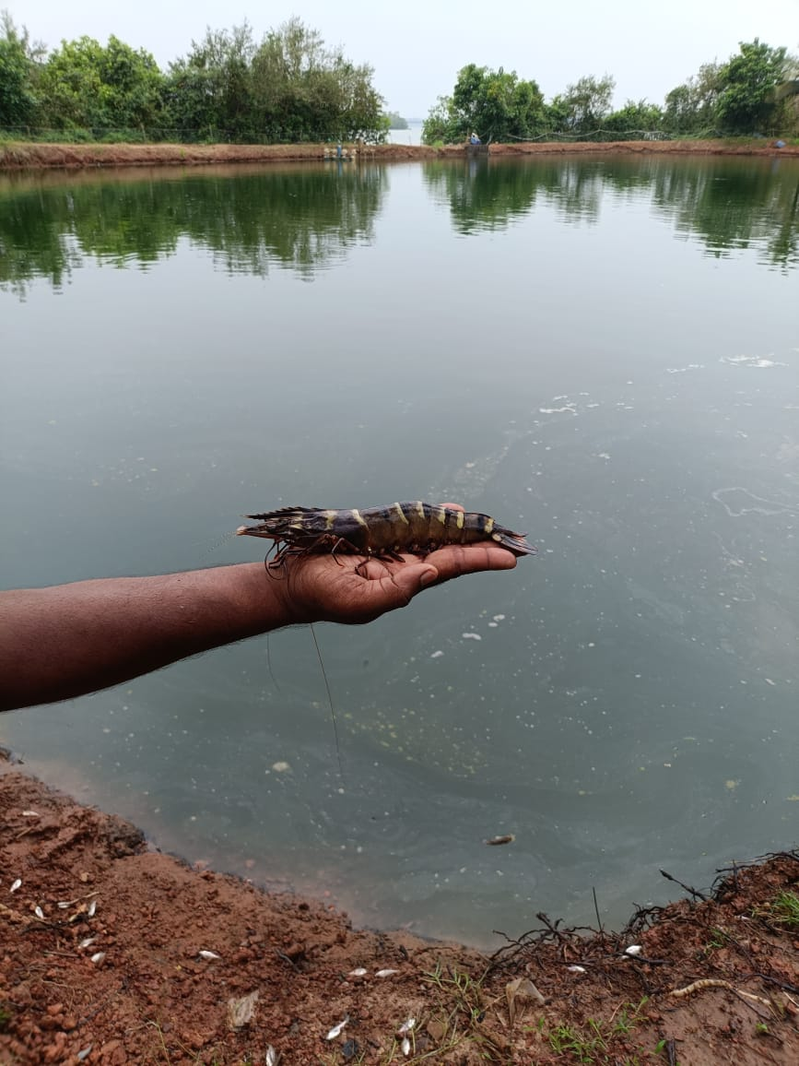

Figure 40 Location 1

* **Coordinates:** 13°41'49.1"N, 74°41'37.0"E (Kundapura)
* **Parameters:**
  + **pH:** 8.2
  + **TDS:** 580 ppm
  + **Turbidity:** 1907 NTU
  + **Temperature:** 29°C
* **Water Quality Index (WQI):** Poor
* **Analysis:** Elevated TDS and turbidity suggest nutrient accumulation, most likely from prawn farming activities, which contribute to high nutrient loads and potential eutrophication. The slightly alkaline pH and high TDS levels indicate that waste and feed runoff may be raising mineral content in the water, impacting water clarity and quality. If untreated, these conditions could harm aquatic life by depleting oxygen levels and facilitating algal growth.

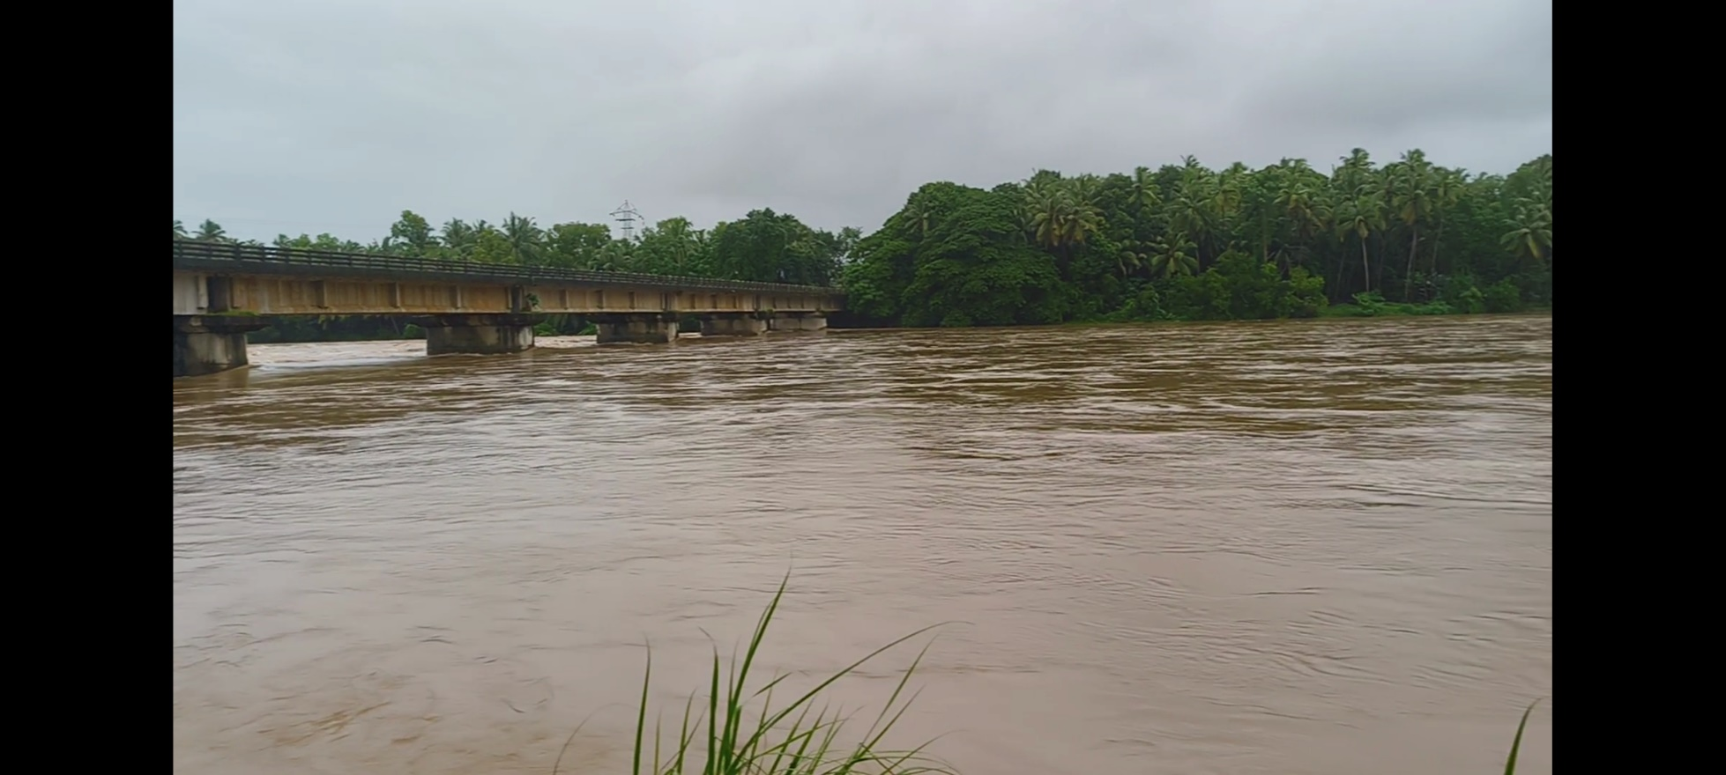**Location 2: Sita River**

Figure 41 Location 2

* **Coordinates:** 13°27'29.0"N, 74°45'03.8"E (Barkur)
* **Parameters:**
  + **pH:** 6.7
  + **TDS:** 270 ppm
  + **Turbidity:** 2015 NTU
  + **Temperature:** 26°C
* **Water Quality Index (WQI):** Moderate
* **Analysis:** The acidic pH level combined with high turbidity points to soil erosion and organic runoff typical of riverine environments, especially during heavy rains. Seasonal variations likely influence these metrics, with higher turbidity resulting from suspended particles and organic material. The moderate WQI signals fluctuating water quality, potentially impacting local biodiversity and requiring ongoing monitoring to address seasonal pollution sources effectively.

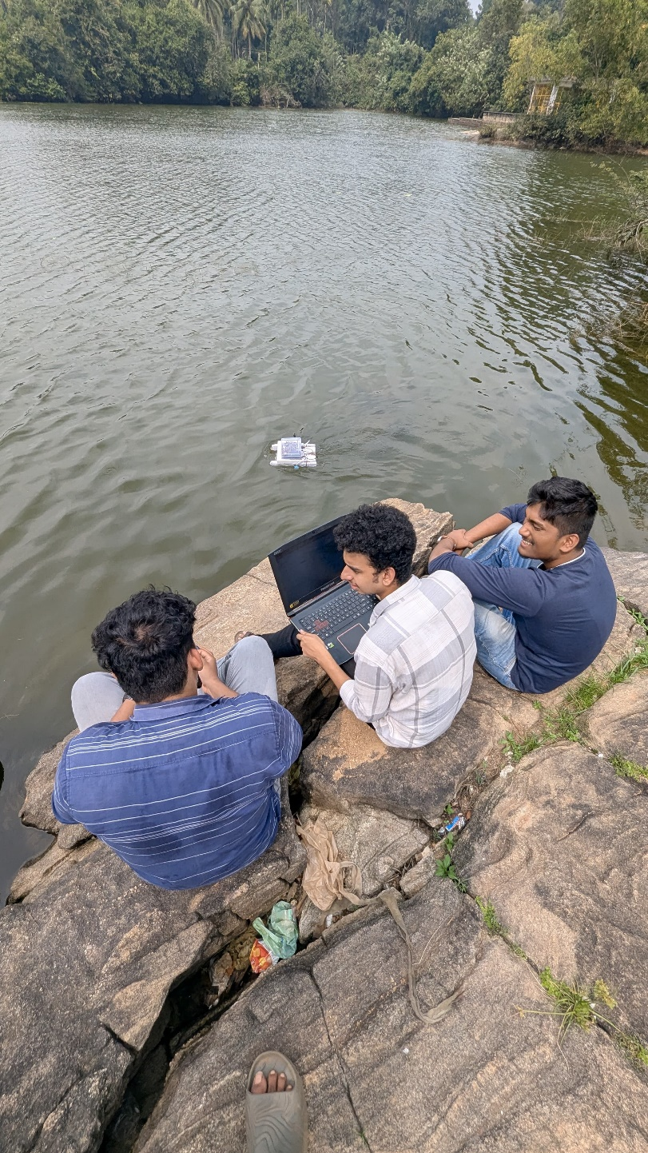**Location 3: Rainwater-Fed Lake (Matadha Kere)**

Figure 42 Location 3

* **Coordinates:** 13°11'41.5"N, 74°59'25.6"E (Karkala)
* **Parameters:**
  + **pH:** 7.2
  + **TDS:** 205 ppm
  + **Turbidity:** 400 NTU
  + **Temperature:** 28°C
* **Water Quality Index (WQI):** Good
* **Analysis:** This lake shows relatively low TDS and turbidity, with a neutral pH, indicating minimal human impact and good water quality. The lake’s high WQI reflects a healthy ecosystem, suitable for sustaining aquatic life without immediate intervention. Serving as a reference for natural water quality, this site supports a stable aquatic environment with limited external pollutants.

**Chapter 7 CONCLUSION & FUTURE SCOPE**

## CONCLUSION

In addressing the specific challenges of environmental monitoring, the unmanned water quality monitoring vessel proves a valuable tool, delivering a real time, readily scalable avenue to water pollution control. Using IoT technology and employing a set of fine-tuned sensors, the system accurately measures the temperature, turbidity, pH level and TDS of the water and sends it to the Arduino Cloud. Such a feature of remote control and supervision guarantees the possibility of immediate actions to prevent damage to water biosystems and to maintain satisfactory water quality for industrial and population needs.

Trials in a prawn farm, a river, and a rain-fed lake showed that the vessel could be versatile in terms of environment and performance in identifying pollution sources and differences in water quality potential. With GPS interface for location tracking, ESP8266 for cloud connectivity, the following benefits are visible: better and accurate positioning as well as user-friendly data visualization. Also, the onboard ultrasonic sensor improves environmental preservation through the identification of floating waste to monitor pollution as well as make relevant proactive waste management.

The project is effective in overcoming the shortcomings of routine water quality monitoring by significantly minimizing the role of sampling and laboratory testing. This system is more useful in the regions which are either hard to access or are contraindicated for human beings to access them. The vessel is modular in design for expansion in the future, in view of requirements of other sampling for environmental monitoring.

In conclusion, the present work offers a solution capable of satisfying present water quality monitoring requirements but also poised for long-term, real-time analysis of the environment. The modularity and IoT-friendly structure of this vessel makes it a potential asset for the regulatory bodies, the environmental protection agencies, and the aquaculture companies to forwardly prompt wiser and improved approaches to the utilization of water resources.

## FUTURE SCOPE

To improve the existing methods, our proposed approach for the Unmanned Vessel for Pollution Monitoring integrates enhanced features and more advanced technologies. The aim is to optimize the efficiency, accuracy, and reliability of water quality data collection, while also improving the vessel's adaptability to various environments.

An improved sensor calibration procedure is essential to this enhancement. We intend to put in place a self-calibration system that automatically modifies the sensors in response to external circumstances. By reducing downtime and the need for manual recalibration, this improvement will enable the vessel to run uninterruptedly for longer periods of time. Even when the vessel is utilized in several water bodies with diverse characteristics, self-calibration will guarantee that the data stays accurate.

For wireless connection, we suggest utilizing advanced IoT protocols like LoRaWAN or 5G to increase data transfer speed and range. These protocols will improve the vessel's ability to communicate over long distances, which makes it perfect for places with unstable connections or big bodies of water. Data transfer that is quicker and more dependable would guarantee that users receive real-time information instantly, which is essential for prompt action when pollution levels surpass safe norms.

We also aim to enhance the **vessel's structural design**, focusing on a more **modular and flexible construction**. This will make it easier to upgrade or replace components, such as sensors or motors, without needing to rebuild the entire vessel. The modular design will allow for quick adaptation to different research needs or water conditions, making the vessel more versatile. This design will also make it easier to conduct repairs, reducing the time the vessel might spend out of service.

Another significant improvement involves the **automation and navigation capabilities** of the vessel. By integrating **machine learning algorithms**, the vessel will be able to learn from past navigation patterns and optimize its routes for more efficient data collection. The vessel could use **GPS and AI-based path planning** to ensure that it covers all necessary areas of a water body, minimizing overlap and focusing on areas of interest. This will increase the vessel's operational efficiency, enabling it to collect more data in less time.

To further improve data accuracy, we propose the use of **data fusion techniques**, where data from multiple sensors is combined to produce a more accurate overall measurement of water quality. This approach will help to **filter out noise** and inconsistencies in the data, providing a more reliable picture of the water’s condition. Data fusion can also help in identifying correlations between different water quality indicators, such as the relationship between turbidity levels and pH changes, giving users deeper insights into pollution sources.

Lastly, our proposal includes the development of a **user-friendly dashboard** for data visualization. This dashboard will display real-time data in an intuitive format, using **graphs, maps, and alerts** to highlight critical information. It will also include options for **custom reports** and **historical data analysis**, allowing users to track changes over time. By making the data easier to interpret, we aim to empower environmental researchers, governmental bodies, and local communities to take more informed actions to combat water pollution.

In summary, our proposed methodology focuses on improving the **precision, scalability, and user accessibility** of the Unmanned Vessel for Pollution Monitoring. Through enhanced calibration, better wireless communication, and a more adaptable vessel design, we aim to create a system that is not only more efficient but also capable of meeting the diverse needs of various stakeholders involved in water quality management. By leveraging automation and advanced data analysis techniques, we believe that this upgraded solution can play a crucial role in protecting and preserving water resources for future generations.

**Chapter 8 REFERENCES**

1. S. Pasika and S. T. Gandla, ‘‘Smart water quality monitoring system with cost-effective using IoT,’’ Heliyon, vol. 6, no. 7, Jul. 2020, Art. no. e04096R.
2. Bogdan, C. Paliuc, M. Crisan-Vida, S. Nimara, and D. Barmayoun, ‘‘Low-cost Internet-of-Things water-quality monitoring system for rural areas,’’ Sensors, vol. 23, no. 8, p. 3919, Apr. 2023,
3. N. A. Razman, W. Z. Wan Ismail, M. H. Abd Razak, I. Ismail, and J. Jamaludin, ‘‘Design and analysis of water quality monitoring and filtration system for different types of water in Malaysia,’’ Int. J.Environ. Sci. Technol., vol. 20, no. 4, pp. 3789–3800, Apr. 2023.
4. Nikhil Kedia, Water Quality Monitoring for Rural Areas- A Sensor Cloud Based Economical Project, in 1st International Conference on Next Generation Computing Technologies (NGCT-2015) Dehradun, India, 4-5 September 2015. 978-1-4673-6809-4/15/$31.00 ©2015 IEEEMhuja, E., & Lee, M. (2022). A Chatbot for Anxiety Management: Development and Evaluation. *Computers in Human Behavior*, 130, 107164.
5. Jayti Bhatt, Jignesh Patoliya, Iot Based Water Quality Monitoring System, IRFIC, 21feb,2016Smith, R., & Hargreaves, A. (2022). The Effectiveness of Chatbots in Mental Health Services: A Meta-analysis. *Psychological Services*, 19(2), 265-274.
6. Michal lom, ondrej priby & miroslav svitek, Internet 4.0 as a part of smart cities, 978-1-5090-1116-2/16/$31.00 ©2016 IEEEIqbal, M., & Masood, A. (2022). Building Trust in AI Chatbots for Mental Health. *AI & Society*, 37(2), 255-269.
7. IoT-Enabled Advanced Water Quality Monitoring System for Pond Management and Environmental Conservation JEETENDRA KUMAR 1 , RASHMI GUPTA 1 , SUVARNA SHARMA 2 , TULIKA CHAKRABARTI3 , PRASUN CHAKRABARTI 4 , (Senior Member, IEEE), AND MARTIN MARGALA 5 , (Senior Member, IEEE) 1Department of Computer Science and Application, Atal Bihari Vajpayee University, Bilaspur, Chhattisgarh 495009, India.
8. Internet of Things (IoT) Based Water Quality Monitoring System 1,Md. Mahbubur Rahman , 2,Chinmay Bapery, 3,Mohammad Jamal Hossain, 4,Zahid Hassan , 5,G.M. Jamil Hossain, 6,Md. Muzahidul Islam 1, 2, 3, Department of Computer Science and Information Technology (CSIT), Patuakhali Science and Technology University, Patuakhali, Bangladesh 4, 5, 6, Faculty of Computer Science and Engineering, Patuakhali Science and Technology University, Patuakhali, Bangladesh.
9. Water Quality Monitoring System Based on IOT Vaishnavi V. Daigavane and Dr. M.A Gaikwad Department Electronics & Telecommunication Engineering, Mtech(VLSI), Bapurao Deshmukh College of Engineering, Sevagram, wardha_442102(M.S.), India.